Improving the passenger experience when trains become ‘stranded’

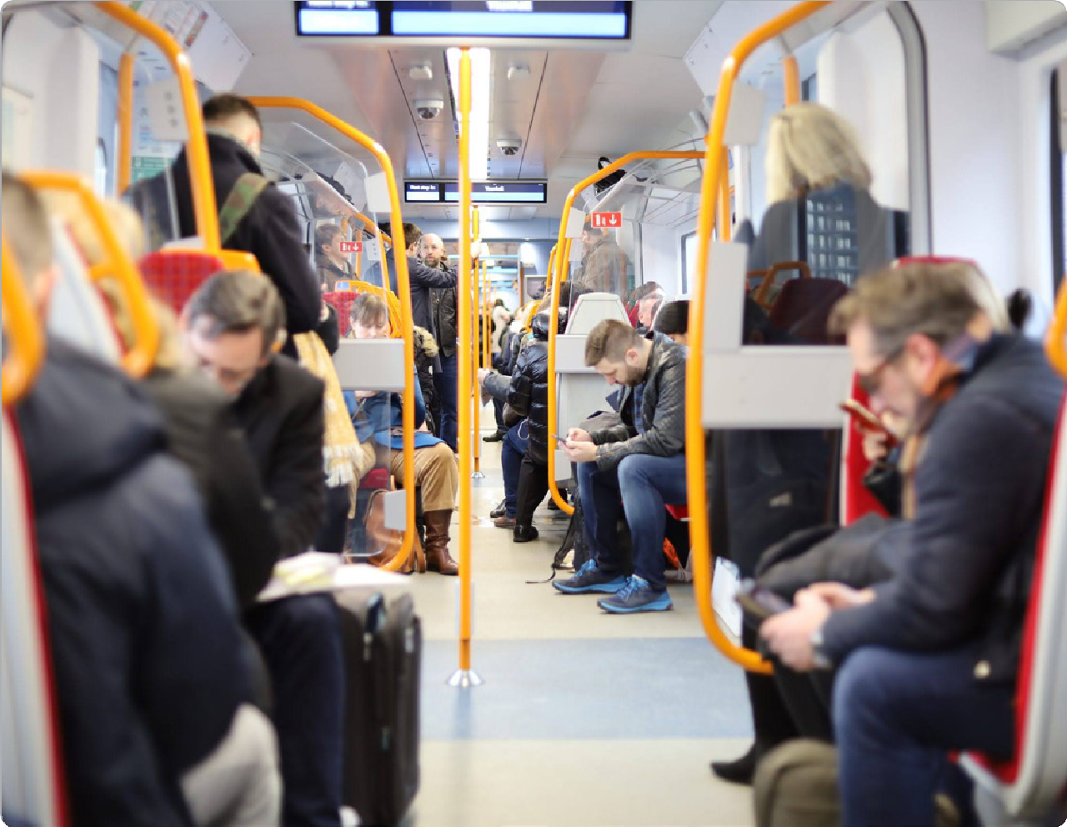

August 2024

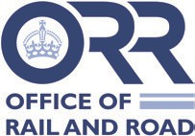

**Improving the passenger experience when trains become ‘stranded’**

# Background

Reports of poor passenger experiences during several ‘stranded trains’ incidents in Autumn 2022 led to concern that passenger safety and welfare may be being compromised. The Office of Rail and Road (ORR) and Transport Focus have worked together to investigate the issue and make recommendations for improvement. We were supported in this work by Steer and the resulting study, summarised in this document, looked at the outcomes from a passenger perspective and examined the effectiveness of the rail industry’s stranded trains guidance1, issued in 2011 and last updated in 2020.

Clearly, the rail industry must ensure that as few trains become stranded as possible, however this study focused on how passengers fare when it does happen. It sought to hear directly from passengers involved in stranded train incidents about their experiences. We are grateful to Trainline, a number of train operators and Transport for London for facilitating introductions to their customers. In addition, we sought the industry perspective from discussions with train operators and Network Rail and examined documented stranded trains procedures. We are grateful for the co-operation shown by the industry.

The definition of a stranded train incident for the purposes of this study was where one or more trains had come to a halt for two hours or more between stations. We purposefully sought to include some incidents where there had been loss of electricity supply to trains. We also sought to include different types of service (for instance long-distance and commuter) and have a spread of geography and train company owning groups.

While the causes of trains becoming stranded were outside our scope, it is useful to note that during the 70-day research period (30th October 2023 to 8th January 2024) there were 75 incidents leading to 178 trains becoming stranded, 20 of which led to passengers being evacuated. On average just over one incident per day, each typically affecting at least two trains. Of the 20 trains evacuated, five required passengers to walk along the track to a station and six – all linked to the same incident – were deemed ‘uncontrolled’, where passengers took matters into their own hands and climbed out of trains. In short, alongside efforts to reduce the incidence of stranded trains, effective management of the incidents that do occur is vital to safeguard passenger safety, welfare and customer experience.

**On average just over 1 incident/day, each affecting at least 2 trains**

**In just over 2 months**

**(30 Oct 2023 – 8 Jan 2024)**

**75 incidents**

**178 stranded trains**



**20 trains evacuated**

**5 trains’ passengers required to walk along the track to a station**

**6 trains’ passengers deemed ‘uncontrolled’, where passengers took matters into their own hands and climbed out of trains**

1 Meeting the Needs of Passengers Stranded on Trains (raildeliverygroup.com)

# The study in numbers

**17** train operators

engaged in the project



**14**

of those agreed to facilitate introductions to passengers likely to have been on stranded trains



**11**

operators provided their stranded train protocols/manual



**4**

case studies were undertaken from those meeting the criteria set



**28**

passengers were interviewed in depth, including eight with additional needs

The four case studies related to the following incidents:

* 7 December – Ladbroke Grove, London, Great Western Main Line
* 7 December – Beattock Summit, South Lanarkshire, West Coast Main Line
* 9 December – Corby Glen, Lincolnshire, East Coast Main Line
* 21 December – Bourne End Junction near Hemel Hempstead, Hertfordshire, West Coast Main Line.

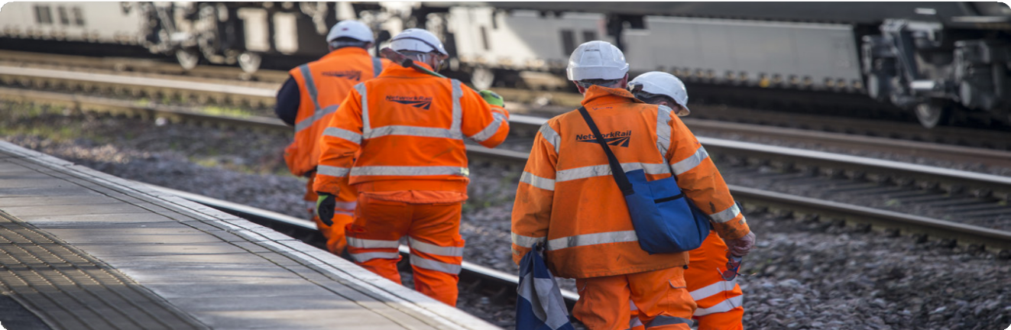

**Improving the passenger experience when trains become ‘stranded’**

# What we found

## In overall summary, the study concluded that:

* + - * The current guidance has, by and large, been reflected in organisations’ written procedures, but there is evidence to suggest:
    - Procedures may not go far enough in some cases to ensure an acceptable passenger experience.
    - Procedures may not always be well executed in practice
    - The Guidance (and therefore procedures based on it) may need to be strengthened.
    - The evidence is mixed that the railway really grasps that delivering as good a passenger experience as possible in a stranded train situation contributes to safety, rather than is at odds with it.
    - Many passengers were remarkably stoical about their experience, often praising the efforts of individual members of front-line staff.

## Expanding on those points, we found that:

* + - * Procedures tend to be written in the context of a single train that has become stranded and may not be adequate to meet the needs of passengers involved in incidents involving several trains.
      * Too little priority is given to ensuring smooth onward journeys once off the stranded train – both in terms of documented procedures and delivery on the ground.
      * The guidance recommends that a plan is created within 60 minutes, but in some circumstances
        + particularly where there is no power to a train
        + that just isn’t fast enough. If it takes an hour to formulate a plan, by the time it is executed trains may have flat batteries (and therefore no lighting, air conditioning, heating or working toilets), so the

onboard experience may be poor and passengers could start climbing out to make their own way to their destination.

* Evidence is mixed that the industry is good at identifying passengers with additional needs (disabilities, health conditions, travelling with young children etc.) in stranded trains situations, including the challenge of identifying less visible conditions
* Although many front-line staff ‘carried the day’ in terms of the relationship with passengers during these incidents, there is evidence that they need greater training in softer communication skills – particularly about how to maintain trust/hope when there is no news or only bad news.

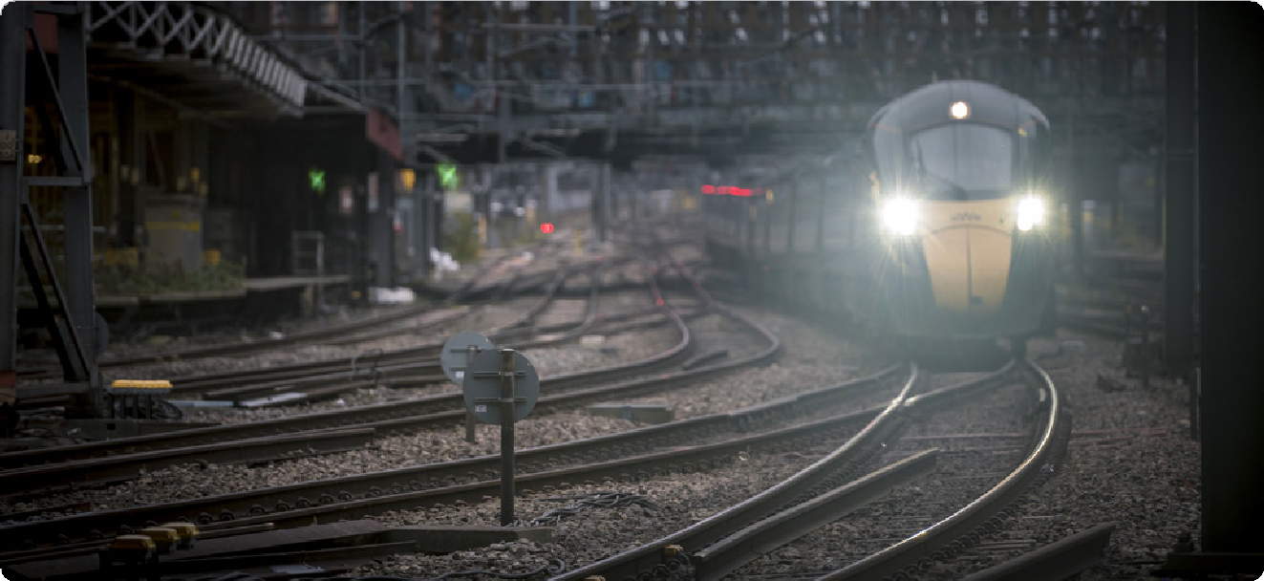

# Next Steps

## Improving the industry’s overall response to stranded trains incidents

* ORR has written to infrastructure providers and train companies asking them to provide assurance that documented plans and procedures for dealing with stranded trains fully reflect the content of existing published guidance and learning from recent incidents, and that they are fully embedded into day-to-day operational practices and arrangements.
* This assurance must include details of simulation exercises that form part of emergency planning arrangements and how stranded trains incidents

and the passenger experience of them are managed. It must also include an assessment of the factors that increase the risk of passengers climbing out of stranded trains unsupervised.

* ORR and Transport Focus intend to bring together senior leaders from infrastructure providers and train companies later in 2024 to discuss the industry’s approach to the management of stranded trains and drive a

collaborative approach to learning lessons from past incidents.



**Improving the passenger experience when trains become ‘stranded’**



## Updating Industry Guidance

* + ORR and Transport Focus are pleased that the industry intends to review and reissue current guidance by November 2024 and explore creation of a maturity model for responding to stranded trains.
  + The review should set an explicit aim that passengers should be rescued (or on the move again) within 90 minutes of a train becoming stranded unless there are clear safety, welfare and customer experience advantages in their remaining on the train.
  + The review should strengthen the requirement to ensure plans and procedures are fit for purpose if a number of trains are stranded in the same area at the same time.
  + It should also review arrangements to evolve the guidance in light of learnings from future incidents, as well as to codify and share good practice on the subject between different parts of the industry.

## Safeguarding passenger safety, welfare and experience when caught up in a stranded train incident

ORR and Transport Focus recommend that the stranded passenger trains element of the industry’s ‘performance for the customer’ programme considers the following:

* Reviewing the various incident response roles, within Network Rail and train operators, to ensure they place sufficient emphasis on the safety, welfare and experience of passengers while on board and once off a stranded train, alongside other responsibilities.
* Reviewing training programmes, including refresher arrangements, to ensure that individuals perform effectively in incident response roles even if called on to do so infrequently in relation to a stranded train.
* Ensuring that the role of the Stranded Train Champion (STC) set out in the industry Guidance is well defined and individuals who will perform the role receive suitable, ongoing training. This should include the circumstances in which an STC should be appointed and how the STC interacts with the incident response structure.
* Whether robust arrangements are in place to identify passengers with additional needs, including but not limited to those with less visible needs.
* Whether use of direct ‘control to passenger’ announcements via the Global System for Mobile Communications-Railway (GSM-R) system is routine where functionality exists, and where it remains pending that it will be introduced at pace. Being able to explain accurately and quickly what has happened, what is being done about it and provide progress reports will minimise passengers’ sense that they have been abandoned and reduce the risk that passengers climb out of stranded trains unsupervised.
* Whether arrangements can be strengthened to ensure a reliable supply of buses and taxis at short notice to rescue passengers and ensure onward travel.
* Whether arrangements are robust to secure hotel rooms at short notice if it becomes impracticable for passengers to complete their journey or return home.
* Whether sufficient individuals, appropriately trained, equipped and empowered, can be mustered to any location required to assist with, among other things:
  + Unlocking passenger facilities at stations, including waiting rooms and toilets.
  + Organising reasonable sustenance for rescued passengers, for example tea/coffee, water and a sandwich.
  + Organising queuing for onward transport, including making best use of resources by grouping passengers travelling to the same destination.

Those individuals must have the means and authority, for example a corporate visa card, to incur reasonable expenditure necessary in the circumstances.

* Whether arrangements to ensure emergency supplies of water, foil blankets and potentially medical supplies are held at strategic locations, with processes in place to transport and distribute them at short notice.

### Contact Transport Focus

Any enquiries about this research should be addressed to:

Guy Dangerfield

Head of Strategy and Intelligence [Guy.Dangerfield@transportfocus.org.uk](mailto:Guy.Dangerfield@transportfocus.org.uk) [www.transportfocus.org.uk](http://www.transportfocus.org.uk/)

Albany House

94-98 Petty France London

SW1H 9EA

Transport Focus is the operating name of the Passengers’ Council

### Contact the Office of Rail and Road

Any enquiries about this research should be addressed to:

The Consumer Policy team [consumer@orr.gov.uk](mailto:consumer@orr.gov.uk) [www.orr.gov.uk](http://www.orr.gov.uk/)

Office of Rail and Road 25 Cabot Square London

E14 4QZ

© 2024 Transport Focus

Design by heritamacdonald.com