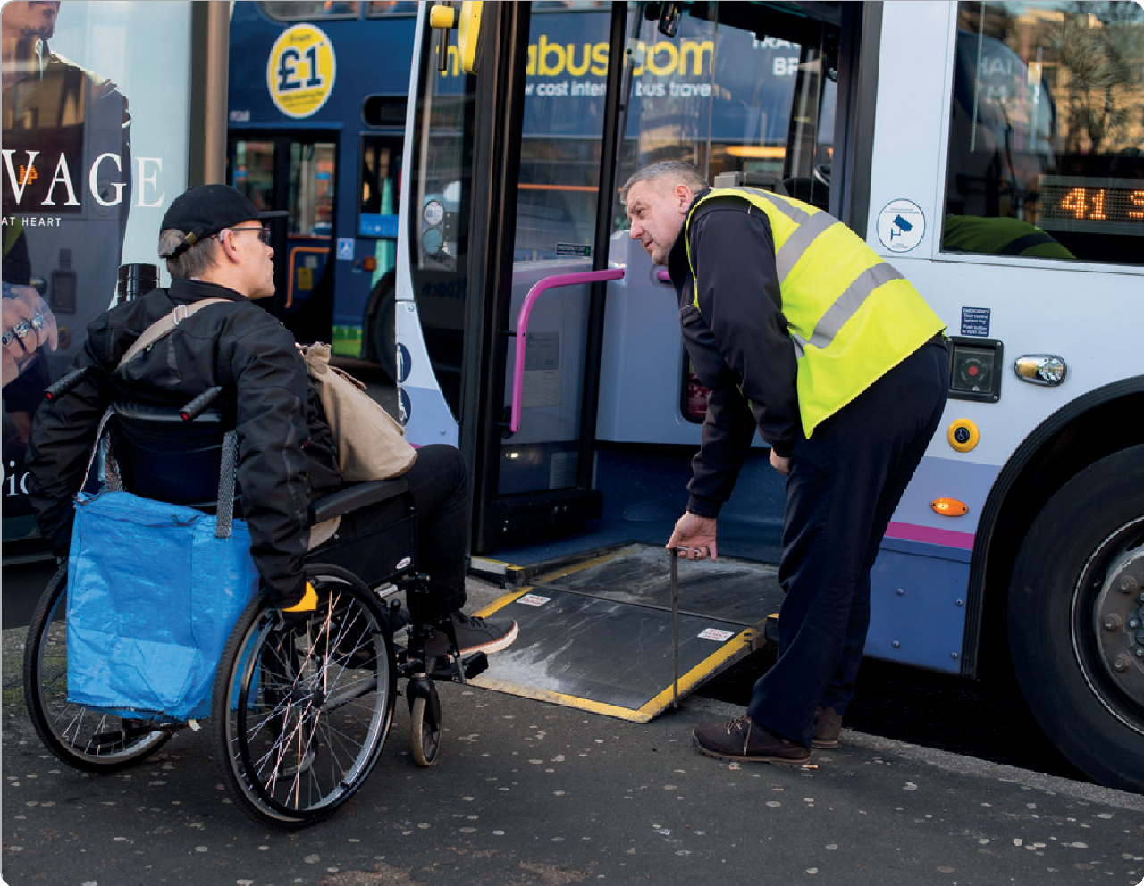

Transport Focus workplan:
April 2022-March 2023

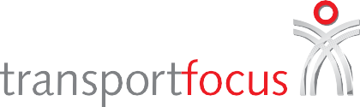

Transport Focus workplan: April 2022-March 2023

Overview

Transport Focus aims to make a difference by making transport better for those who use it and those who could possibly use it. The challenges facing the transport world in 2022-23 are significant, requiring long-term changes with ambitious policies to help deliver that change.

During 2021-22, decarbonisation of transport became the biggest long-term challenge with COP26 and Government priorities set out in the Transport Decarbonisation Plan, Transport Scotland’s Rail Services Decarbonisation
Action Plan and the Welsh Government’s A route map for decarbonisation across the Welsh public sector. The
question now is how the transport sector decarbonises and how consumers are taken on that journey.
Also, major reforms to rail in Great Britain and bus in England will roll out during 2022-23. These are
expected to bring improvements for passengers, making them attractive ways to get around and providing more sustainable choices.
Transport Focus – the transport user watchdog
Making a difference by being useful, relevant, consumer-focused and evidence-based
Our role is to ensure that the user view is at the heart of these changes. We reflect back transport user attitudes and experiences to decisionmakers and providers of transport so they can better meet users’ needs.
Transport Focus has identified these opportunities in the coming year:
- contributing the user view on changes arising from, in particular, the Transport Decarbonisation Plan and similar initiatives in Scotland and Wales, the creation of Great British Railways, the National Bus Strategy in England and developments in electric vehicle (EV) charging
- leading the debate about climate-related behaviour change in transport
- continuing to develop cutting-edge, rapid, cost-effective insight that is representative of transport users, providing speedy feedback.

In the light of these opportunities and challenges in the transport world, we set out our workplan for 2022-23.

To support the delivery of these outcomes, we will:
- continue refreshing our insight, adapting it to new circumstances and creating new and innovative products which are useful to those who make decisions about transport
- improve the diversity of those we talk to in our insight and those we employ and work with
- operate a well-run, well-governed and effective organisation that is seen and heard by transport users and decision makers
- monitor the impact of the Covid-19 pandemic and its impact on transport users and the organisation as necessary.

Overarching theme: decarbonising transport
Outcome 1 | Outcome 2
Transport decarbonisation policies taking account of the user. | Rail - improved passenger experience and increased use, particularly arising from rail reform.
Outcome 3 | Outcome 4
Bus - improved passenger experience and increased use, particularly arising from bus reform. | A more reliable strategic road network improving satisfaction for its users.

Our outcomes for 2022-23

Outcome 1: transport decarbonisation policies taking account of the user
We will do this through
- conducting research into the consumer experience of charging electric vehicles on National Highways’ roads including a benchmark for measuring future change
- researching consumer views about paying for road use as we move to a post-fossil fuel era
- contributing to the debate on behaviour change and transport through a series of webinars
- ensuring that rail and bus service reforms result in attractive forms of sustainable transport for passengers (see outcomes 2 and 3).

To achieve decarbonisation in transport, users’ attitudes and experiences must be at the core of any changes. Consumers face barriers, as we have seen with the take- up of electric vehicles (EVs) and their charging. We will be conducting research into the consumer experience charging an EV at services on National Highways’
roads, covering different chargepoint operators. This will establish a benchmark from which we can measure future change.
We have begun gathering insight on transport users’ views and attitudes towards sustainable transport and this will continue.

Outcome 2: rail - improved passenger experience and increased use, particularly arising from rail reform
We will do this through
- working with the Department for Transport to shape the rail reform plans and with Great British Railways as it implements reform delivery plans
- transforming our own structure to take on new passenger champion responsibilities including monitoring and investigating passenger concerns and escalating where necessary, getting more involved in monitoring passenger complaints
- working on reforming rail fares, retailing, ticketing and rollout of contactless payments.

The implementation of the ambitious Williams-Shapps Plan for Rail will progress in 2022-23, starting to make a
difference to passengers in England. Transport Focus will evolve to take on new passenger champion responsibilities.

Outcome 3: Improved passenger experience and increased use, particularly arising from bus reform
We will do this through
- engaging with the progress of bus reform
- building on our partnership working with local transport authorities (LTAs) and other bodies, continuing to provide appropriate advice and support
- developing our new bus passenger satisfaction survey for use by LTAs and others to benchmark their services and measure the impact of investment and other activities.

The National Bus Strategy for England provides an opportunity to improve bus services for passengers. It will move towards implementation in 2022-23.
We have already engaged with nearly all local transport authorities (LTAs) to help them develop passenger- focused plans.

Transport Focus workplan: April 2022-March 2023

Outcome 4: a more reliable strategic road network improving satisfaction for its users
We will do this through
- using our insight, particularly on user priorities for improvement, to advise on the development of the third Road Investment Strategy
- launching a new, ongoing survey to assess lorry driver satisfaction with, and priorities for improvement to, roadside facilities along National Highways’ roads, including motorway service areas, ‘A’ road services and truck stops
- continuing to survey the consumer experience using National Highways’ roads through the Strategic Roads User Survey, the Logistics and Coach Survey and our cyclists, pedestrians and equestrians research
- producing additional road user insights into perceptions of safety, as referenced in the Government’s response
to the Transport Committee smart motorways recommendations, and carry out any new research that is required.

National Highways’ roads are crucial for the country’s wealth and our wellbeing. Understanding the views
of users, whether in a car, coach, lorry or van, on a motorbike, bicycle or horse, or on foot, is crucial to the effective operation of these roads.
Key issues in 2022-23 include ensuring road
users’ views are at the heart of discussions about the Government’s third road investment strategy (RIS3) for 2025-30. The lorry driver shortage has highlighted the importance of improving roadside
facilities for lorry drivers so we will provide new insight on that subject.

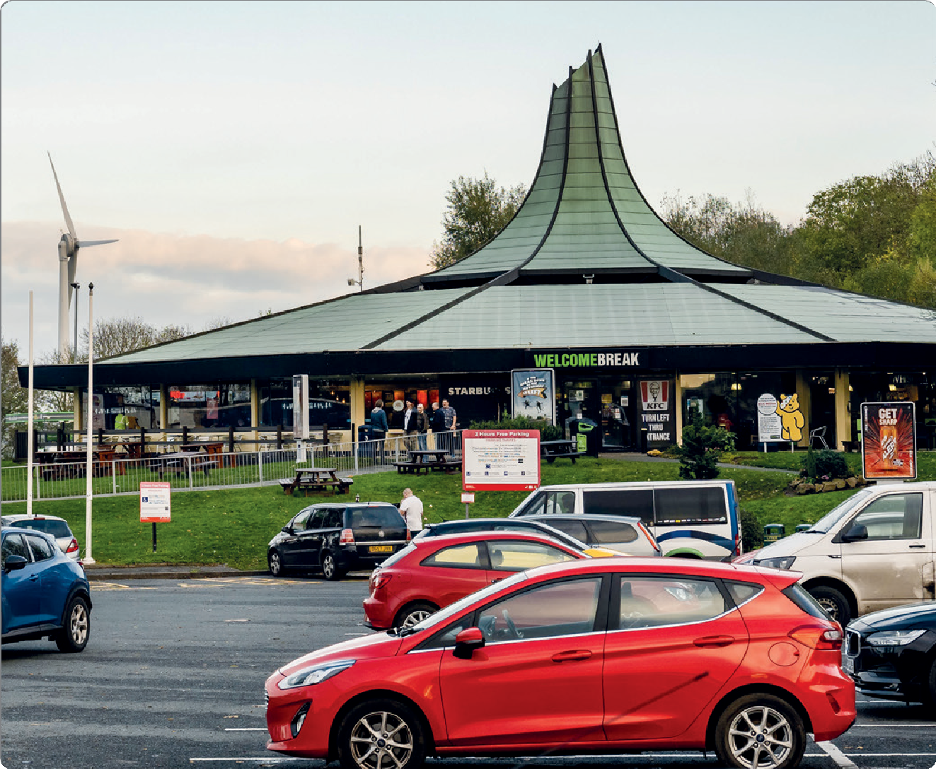

How we will support the delivery of these outcomes

Continue refreshing our insight, adapting it to new circumstances and creating new and innovative products which are useful to those who make decisions about transport
We will do this by:
- continuing to respond to transport user needs and adapt to a fast-changing world with more agile, speedy, digital ways of gathering the user experience
- developing our new, faster, rail and bus passenger satisfaction surveys in order to analyse the data for more targeted, immediate and effective interventions
- continuing to apply segmentation and exploring specific issues in greater depth with our Transport User Panel.

Insight underpins everything we do. We continue to respond to the needs of transport users and learn about and adopt new methods. We demonstrated our ability and
willingness to adapt to a fast-changing world during the Covid-19 pandemic.

Improve the diversity of those we talk to in our insight and those we employ and work with
We will do this by:
- analysing our data and our refreshed and expanded Transport User Panel so we can better understand the needs of different types of transport users, such as those who are disabled or who are from seldom heard groups.
- identifying new partners and stakeholders so as to engage with different representative groups such as members of the National Highways’ Roads for All Forum
- promoting accessibility for disabled transport users in initiatives arising from the Williams-Shapps Plan for Rail
and the National Bus Strategy.
And also improving the diversity and inclusion of our Board and staff, including through recruitment processes.

While all our work benefits all transport users, the organisation is committed to understanding the needs of the seldom heard and those with disabilities so we can be
fully representative. We also must strive to ensure that the makeup of our own organisation is diverse.

Operate a well-run, well-governed and effective organisation that is seen and heard by transport users and decisionmakers
In particular, we will:
- ask our stakeholders what they would like to hear from us about and boost our engagement with elected representatives
- expand our communications reach with more consumers and stakeholders through the use of more social media, videos and podcasts as well as meetings (face to face and digitally) and using new innovative channels
- continue working with our partner organisation London TravelWatch to deliver more integrated transport user representation and better value for money by sharing back office functions.

Engagement with our stakeholders and transport users is an important element in our effectiveness and ability
to make a difference for transport users.

Transport Focus workplan: April 2022-March 2023

Monitor the impact of Covid-19 on transport users and the organisation as necessary

We will do this by
- ensuring any changes in service patterns to reflect new demand levels are informed by data, evidence and consultation with users and communities
- developing and trialling more hybrid working to maintain safe and flexible post-Covid-19 working.

The nature of Covid-19 is that there is uncertainty about both its intensity and impact on the way people travel and on the way Transport Focus works.

Appendix A: further information about specific projects

Researching consumer views about paying for road use as we move to a post-fossil fuel era We will carry out research to understand the consumer view about paying to use roads in future as the revenue from traditional sources like fuel duty and vehicle excise duty declines.
We will also look to measure the consumer experience where there is already a specific charge. We will cover, among other things, payment, information and handling of disputes. We will start with the Dartford Crossing on the National Highways network. We will seek to expand this to cover charges to use bridges and tunnels that, while not part of the SRN, are integral to its use. And we will investigate how this approach could be used, subject to funding, to measure consumer experience using the M6 toll motorway and roads covered by schemes such as the London congestion charge.

Benchmarking the consumer experience of charging an electric vehicle (EV)
Having piloted it in early 2022, we will launch our new survey of the consumer experience charging EVs on National Highways’ roads, producing a benchmark from which to measure improvement. This will give insight into
what works for consumers and what needs improvement, covering different locations and chargepoint operators. It will drive focus on the end user and improve standards.

Measuring the lorry driver experience at roadside facilities
During 2021 the shortage of lorry drivers highlighted the need to improve the roadside facilities available to them, as part of efforts to improve recruitment and retention of staff to the profession. Having piloted it in early 2022, we
will launch our new survey to assess lorry driver satisfaction with and priorities for improvement to roadside facilities along National Highways’ roads. This will include motorway and major ‘A’ road services as well as truck stops. It will improve standards by shining a spotlight on lorry drivers’ experiences.

Improving information on accessibility for disabled road users
We will pilot work to improve the information transport operators provide for their disabled customers about the accessibility of their operation, starting with motorway service area operators and building on initial work undertaken by National Highways.

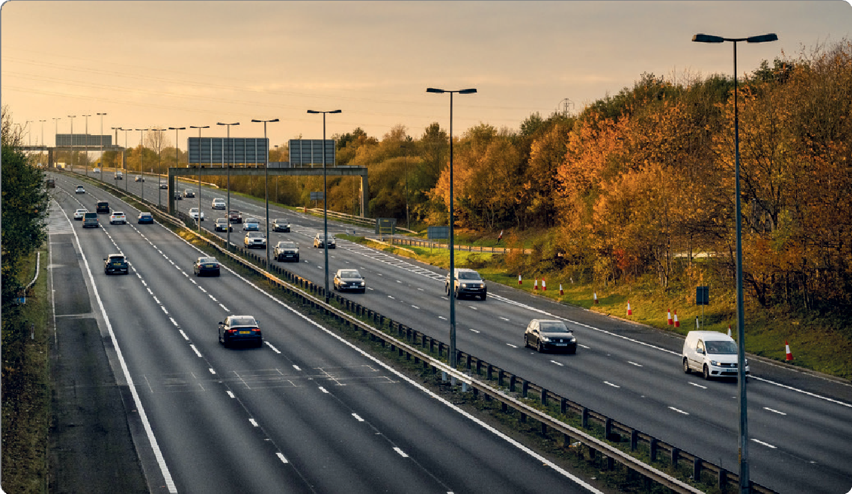

Transport Focus workplan: April 2022-March 2023

Appendix B: ongoing work

Rail
We will continue
- working with DfT on rail contracts
- handling appeal complaints
- working to improve passenger information, particularly at times of disruption
- representing passengers’ views in Network Rail’s business planning/Control Period 7 plans, providing insight on passenger priorities where needed.
- boosting the rail user voice for some train companies who fund additional consumer representation on behalf of their passengers
- representing passengers’ interests when changes are proposed to licence conditions and policies, such as Accessible Transport Policies, National Rail Conditions of Travel, ticket office opening hours, complaints handling procedures and Penalty Fare schemes.

Road
We will continue
- working with National Highways’ regional and other teams to ensure that road users’ views are heard and understood and that where appropriate specific issues are addressed
- ensuring ongoing focus with National Highways on addressing recommendations Transport Focus has made following previous research, including on smart motorways
- holding our Road User Panel where stakeholders representing a wide range of users of National Highways’ roads come together to discuss current issues.

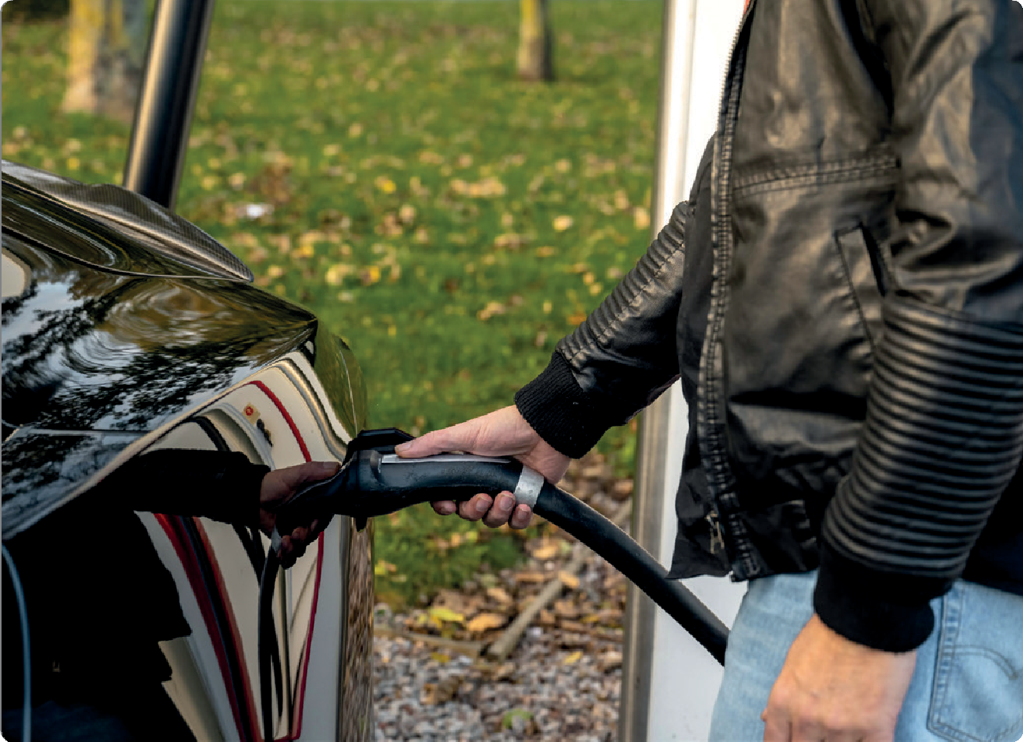

Transport Focus will carry out extra work on behalf of those using Great Western Railway, Greater Anglia, Northern Trains, South Western Railway, TransPennine Express, West Midlands Trains, Transport for Wales and Network Rail Wales.

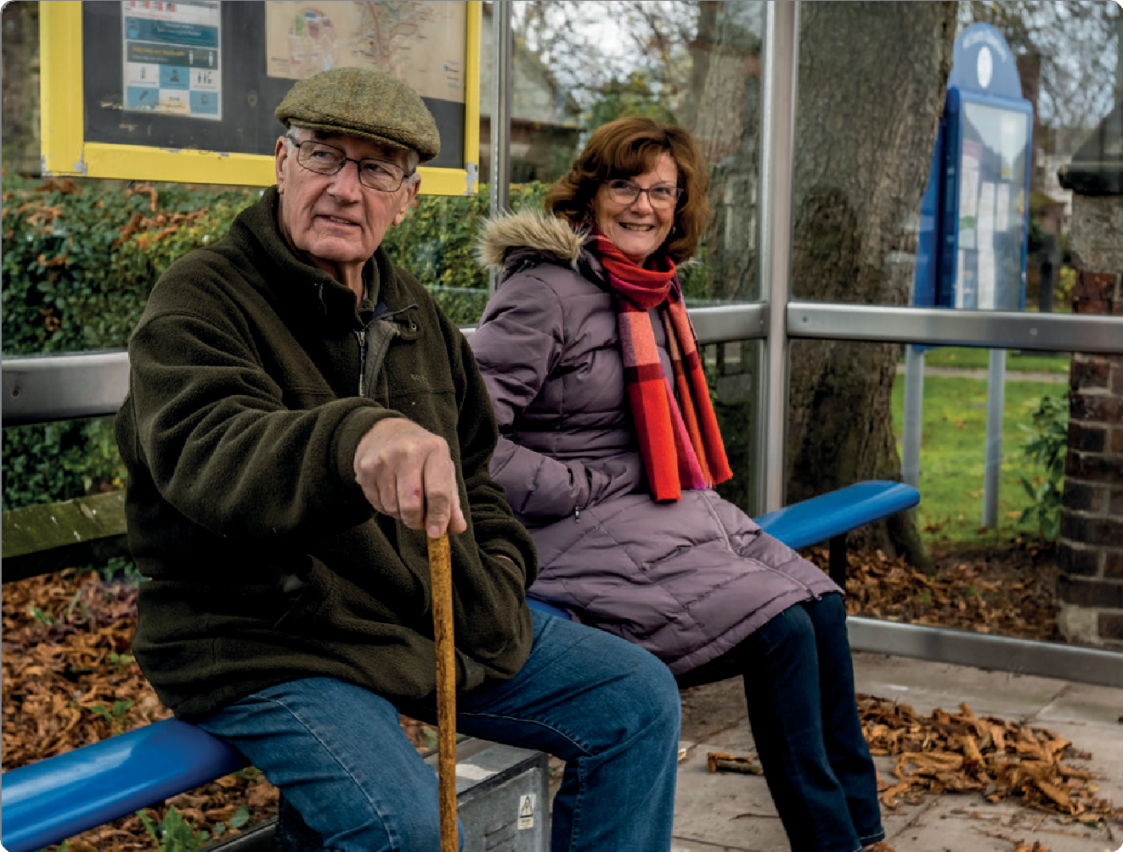

Communications and stakeholder engagement
We will continue to:
- run our 24/7 press office
- manage the website and social media channels, so as to bring the work of Transport Focus to the attention of those who need it in new ways
- update our popular data hub and the new ‘barometer’ dashboard
- produce our high-quality publications output, including insight reports and stakeholder newsletters
- support and promote events such as popular webinars and in-public Board meetings
- explore opportunities to run large-scale consumer- facing campaigns where appropriate.

We will continue advocating for transport users at different geographical levels as tough decisions on long-term public transport priorities are made. In Scotland and Wales we represent transport users on:
- Scotland Rail Task Force
- Transport for Wales Advisory Panel (chair)
- Welsh Government Transport Performance Board.

In England we represent transport users on strategic bodies across major city regions and counties:
- West Midlands Bus Alliance (chair)
- Mayor for Greater Manchester’s Transport Board
- Bristol City Transport Board (co-chair)
- Liverpool City Region Bus Alliance
- West Yorkshire Bus Alliance
- Cambridgeshire and Peterborough Combined Authority Bus Partnership
- Cornwall Bus Partnership Board
- Transport for the North’s Partnership Board.

The organisation will continue to be supported through
an operation that provides excellent governance facilitating the involvement of our Board and ensuring we are accountable and transparent to our stakeholders.
We will ensure the appropriate money, people and systems are directed to efficiently delivering the objectives set out in this workplan through the advice and support provided by our professional finance, human resources and facilities teams.

Contact Transport Focus www.transportfocus.org.uk Albany House
86 Petty France London
SW1H 9EA

Transport Focus is the operating name of the Passengers’ Council

© 2022 Transport Focus Print by priority.co.uk
Design by heritamacdonald.com

