Beyond social distancing: building confidence in public transport
September 2021

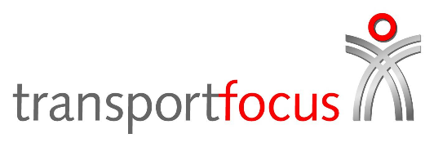
Summary

Transport Focus set out to understand how passengers were feeling about public transport as Covid-19 restrictions eased. We used the interim findings from May to input into the Government’s social distancing review. We followed up with the same passengers at the end of July to see if and how views have changed.

Key findings

- Attitudes towards Covid are changing and people are becoming more relaxed. However, people are still at very different stages in this process, from those ready to move on from Covid-19 completely, to those who still need more reassurance to feel safe using public transport again.
- Space for social distancing is still important, but people appreciate it often won’t be practical on public transport. People are focused instead on what they can control. For now, wearing a mask or face covering is the key safety measure more nervous passengers are relying on to help them feel safe.
- Transport operators should not ‘rush back to normal’. Operators need to keep up additional Covid-19 measures and communications to reassure passengers and help them feel safe.
This research has added depth to our existing insight on how people feel about public transport. Findings from our regular Travel during Covid-19 survey (wave 58 - 7-15 August) are highlighted throughout this report.

How do people feel about the end of restrictions?

We heard how some people were completely ready for life to get back to normal. Many others still felt cautious and told us they would have preferred more restrictions to have stayed in place for longer.

“I think I sort of understand why they’ve done it now… But they could have phased it out….” Male, 31, Nottingham

Many of those who felt it was time for life to get back to normal had continued to use public transport regularly. They were glad to just ‘get on with it’ and are happy that the level of risk posed by Covid-19 was manageable – especially now most people are vaccinated. On the other hand, a few of the more nervous passengers said they had actually avoided public transport immediately following the easing of restrictions. They were anticipating an increased risk of catching Covid-19, at least initially. Many others had continued to travel while doing what they could to help themselves feel safe.

What are people doing to help themselves feel safe?

People feel they can’t control other passengers or the environment on public transport, but they can take their own steps to help them feel safe. Using hand sanitiser remains popular, despite some recognising the scientific evidence that airborne transmission is more important than surface contact. The act of carrying a physical bottle and applying hand sanitiser gives people reassurance and helps them feel in control.

“I know I will use hand sanitiser on public transport for the rest of my life… people who are selfish and don’t want to put a mask on or use sanitiser that’s fine but respect those who do… it does annoy me and I would love to say something but it’s not my place to tell others to conform… as long as I can keep myself and my family safe as much as I can I will.” Female, 62, Manchester

Face coverings or mask use dominated much of the discussion about feeling safe on public transport. People often had strong views and most still wanted masks to be compulsory on public transport. For those not using public transport regularly, anxiety about other people not wearing masks was one of the main concerns they voiced.
This feedback illustrated how face coverings have become an important and relatively easy way for people to feel ‘Covid safe’. Wearing a mask has become an ingrained behaviour for many, with people choosing to wear a mask for three main reasons:
1. personal protection – to reduce the chance of catching Covid-19
2. social pressure – feels like people are judging you for not wearing a mask
3. it is the ‘new normal’ – it is hard to change habits.
Masks have gone beyond a practical measure. They are now a visual sign to communicate feelings towards Covid safety – whether an attempt to signal consideration to others or for other passengers to try to keep at a distance.

One in two say they won’t use public transport unless passengers are required to wear face coverings.
Seven in 10 train passengers and eight in 10 bus passengers reported wearing a face covering at all times on their most recent journey.

“I have been double jabbed so I’m happy to travel on public transport without a mask on... it makes a big difference.” Male, 47, Cardiff
“Nobody was looking at me or judging me for not wearing a mask, but I just felt really awkward without it being on… maybe I feel conditioned to still wear it and feel naked without it.” Female, 49, Hull

Perhaps surprisingly, the easing of social distancing attracted less discussion. It’s still clear that most people want to try and protect their personal space. Those with flexibility will avoid busy times to maintain social distancing. However, the relaxation to the rules on social distancing feels more natural, gradual and inevitable. Many understand that as public transport becomes busier social distancing becomes harder. In contrast with mask use, almost everyone recognises that it simply isn’t practical to ensure social distancing is always possible. People are adapting to social contact being reintroduced and some are increasingly comfortable – though often only if masks are being used – practicing social distancing ‘if possible’ rather than always.

Perhaps surprisingly, the easing of social distancing attracted less discussion. It’s still clear that most people want to try and protect their personal space. Those with flexibility will avoid busy times to maintain social distancing. However, the relaxation to the rules on social distancing feels more natural, gradual and inevitable. Many understand that as public transport becomes busier social distancing becomes harder. In contrast with mask use, almost everyone recognises that it simply isn’t practical to ensure social distancing is always possible. People are adapting to social contact being reintroduced and some are increasingly comfortable – though often only if masks are being used – practicing social distancing ‘if possible’ rather than always.

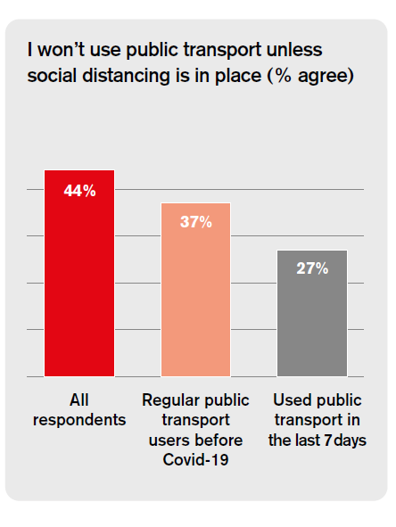

How do people decide whether to use public transport?

Attitudes towards Covid-19 are changing and many people are becoming more relaxed over time. However, proximity to strangers and the lack of control over the shared space on board mean that public transport is still perceived to be a riskier environment.

People weigh up the risks and benefits before travelling and make a judgement about whether using public transport is worth it. People often consider:

- the risk of catching Covid-19 and the potential consequences
- the overall travel experience and how comfortable it is
- the cost, time and effort of travelling at all, especially for commuting.
“I need a good reason to want to spend £25 to work and back, when the other option is to spend nothing and work from home.” Male, 31, Nottingham

People face uncertainty in these decisions and have to make judgements – not necessarily conscious – about questions like: ‘How much control do I have over the risk? How busy will it be? Will other passengers be wearing masks? Will it be clean?’

In principle people will use public transport if the reward for travelling is high enough to outweigh the uncertainty. Often this is more about the destination and reason for travel than how they get there. However, it’s important to recognise that in practice human decision-making isn’t always rational, it can be emotional or impulsive. There are inconsistencies in people’s attitudes and behaviours. For example, some people remain uncomfortable using public transport, but are comfortable in other settings where the rewards may be greater, for example when visiting pubs or restaurants.

In January 2021 three in 10 said they weren’t using public transport because they don’t feel safe, which has decreased to less than two in 10 now.

Around three in 10 are as comfortable now using public transport as they were before Covid. A further two in 10 say they will be as comfortable as before within the next six months.

Around two in three people who travelled by public transport in the last seven days say they are as comfortable now using public transport as they were before Covid.

What do passengers want from operators to help them feel safe?

Set clear expectations and guidance

People want to know what to expect and what is expected of them to try to manage the uncertainty involved in using public transport. They expect operators to provide clear guidance and cues to help encourage passengers to be Covid-safe.

At the peak of restrictions the rules were clear and very widely supported. Today, people are trying to navigate through a more complex landscape. While people have grown used to different rules for different types of places, many would appreciate greater clarity and consistency in approach across public transport.

“I haven’t been using public transport regularly as we have had a lot of cases near us and as I have health problems, I would prefer not to take a chance. I think it is silly that different companies are all doing different things, and nobody knows what they should be doing, so it does put me off using public transport as I still feel the need to distance and wear a mask and I don’t want someone just getting on and sitting next to me.” Female, 36, Hull

Visible signs to help reassure passengers

Feeling safe on public transport is as much emotional as it is practical. People need to see evidence of the efforts operators are making to feel the full benefit. For example, it’s more important than ever that public transport is clean, but passengers feel most reassured by seeing cleaning happening for themselves.

Although some recognise that ‘hygiene theatre’ may not be that effective in reducing the likelihood of catching Covid, it still makes most feel better about travelling. This same idea can be applied for other visual and tangible cues:

- provide free hand sanitiser and even masks for passengers
- display signs, posters or make announcements to reinforce guidance on mask use, inform about cleaning rotas or ventilation systems.

“I would like companies to continue supplying cleaning supplies like hand sanitiser to passengers, and reinforcing the need to be safe, despite social distancing going away.” Male, 21, London

“It’s not always possible to distance on public transport and that can’t be helped but good ventilation, sanitisers on board and perhaps more notices about wearing masks will remind people what they should be doing.” Female, 37, Nottingham

Support people to try public transport again

For some there is still a need to break down travel barriers and remove anxiety and fear of the unknown. For the most Covid-cautious only time and a reduced number of Covid cases will be enough for them to feel safe to use public transport.

However, for others, there may be an opportunity to incentivise travel – perhaps with links to destinations and activities where the perceived rewards are greater. Changes in attitudes can follow changes in behaviour. One good experience on public transport could be all it takes to reassure them and restart habits again.

Around nine in 10 passengers say they felt safe when they travelled by train or bus in the last seven days.

Of those people that were regular public transport users before the pandemic, four in 10 do not feel enough is being done to ensure coronavirus safety on public transport.

Research objectives and method

We wanted to speak to people to gain an in-depth understanding of how people feel about public transport, including:
- the experience of travelling as restrictions eased throughout the summer
- views and experiences on continuing social distancing and wearing face coverings
- whether attitudes towards public transport are different to other public places and why
- how people make decisions about using public transport
- what transport operators can do to encourage people to use public transport.

Throughout the summer we spoke to the same people as restrictions eased to understand how they feel about using public transport and what helps them feel safe. This included:
- eight online focus groups at the end of May and another eight with the same participants at the end of July
- an online community to keep up the discussion with the 46 respondents
- four depth interviews with non-internet users.
We spoke to a wide range of people from across England, Scotland and Wales. This included a mix of older, younger and disabled people, and a range of travel habits, from regular travellers to people avoiding public transport during the pandemic.
Further details on this research are available in the research agency report.

Contact Transport Focus

Any enquiries about this report should be addressed to:
Jordan Sargeant
Senior policy advisor
Jordan.sargeant@transportfocus.org.uk
Transport Focus
Albany House
86 Petty France
London
SW1H 9EA
www.transportfocus.org.uk
Transport Focus is the operating
name of the Passengers’ Council

Transport Focus is the independent consumer organisation representing the interests of:
- bus, coach and tram users across England outside London
- rail passengers in Great Britain
- all users of England’s motorways and major ‘A’ roads (the Strategic Road Network).
We work to make a difference for all transport users.

