Accessible transport: unlocking a better normal
April 2021

Introduction
Throughout the pandemic, Transport Focus has been speaking to people to understand the impact of Covid-19 on transport use and future travel plans. We wanted to explore the views of disabled transport users so that we can help operators make things better as we emerge from the pandemic.
We asked disabled and non-disabled members of our Transport User Panel to complete an online survey asking about public transport use before and during the Covid-19 pandemic. This summary highlights the key findings from this research.

Provision of transport and ease of use
Overall, panellists rated the provision of public transport in their local area positively. There was little difference between disabled and non-disabled respondents. The majority rated services as very or fairly good (69 per cent disabled and 74 per cent non-disabled). 17 per cent of disabled respondents and 14 per cent of non-disabled respondents rated services as very or fairly poor.
However, disabled people don’t find it as easy to use public transport in their area. 53 per cent of non-disabled respondents say it is very easy, compared with 36 per cent of disabled respondents. A higher proportion of disabled respondents say it is difficult. The reasons they gave included the distance to the bus stop being too far for them to manage and greater complexity for journeys with more than one part.
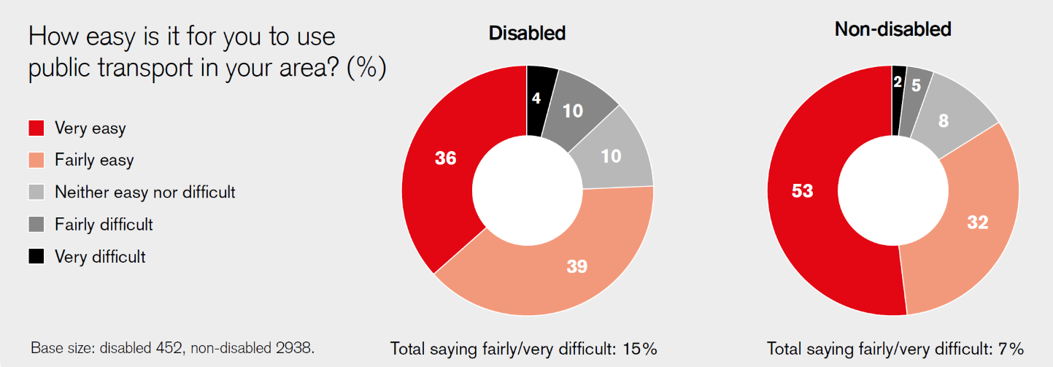

Access to a car
45 per cent of disabled respondents said they have frequent access to a car compared to 66 per cent of non-disabled respondents.
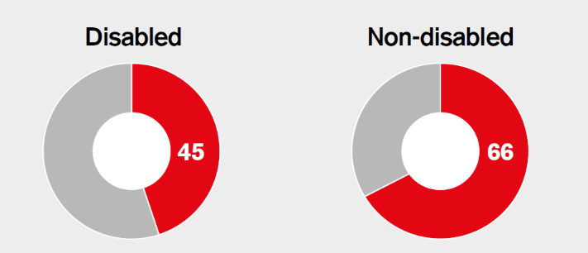

Impact on work and other opportunities
We also wanted to understand how public transport affects access to work and other opportunities for disabled people. 27 per cent of disabled panellists agreed that local public transport provision limited their access to employment opportunities, compared with 18 per cent of non-disabled panellists.
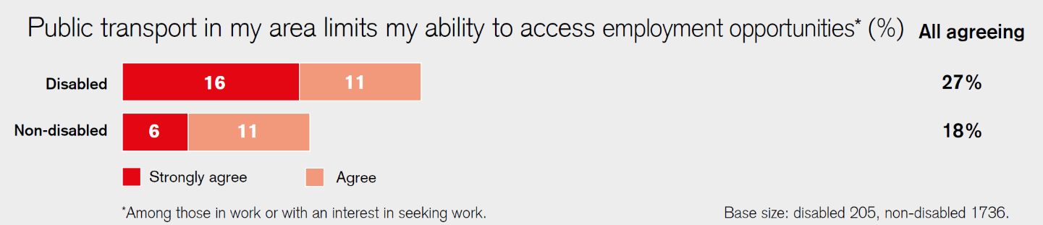
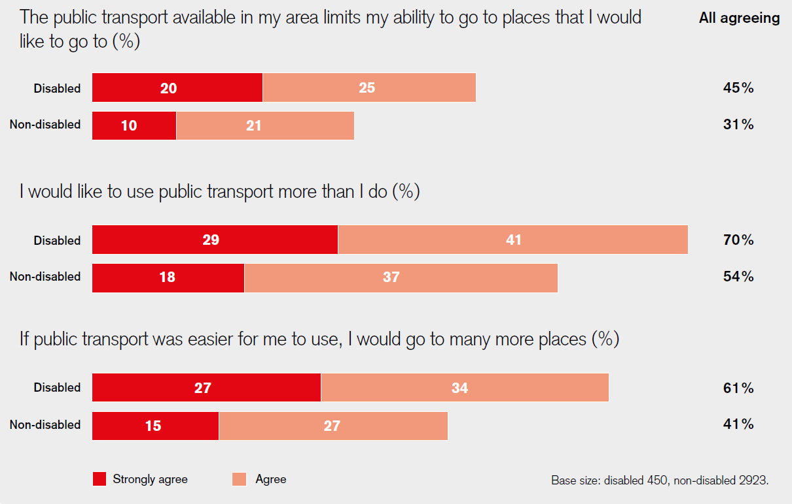
A significantly higher proportion of disabled panellists reported that public transport limits their ability to go places. This means that they do not use public transport as often as they would like and they would go to many more places if public transport was easier for them to use.
Comments from panellists included:
“I am disabled and I find getting on and off buses and trains quite difficult without assistance. I do have a mobility scooter but it is not allowed on public transport, buses or trains, so I am still not able to travel out of my own area.”
“There is a bus every half an hour and it is frequently late or missed out altogether. For vulnerable passengers this can mean a wait of an hour. The service stops early evening so no nights out and Sundays it is every 2 hours with no connecting services without a long wait.”
“Buses near my house have been cancelled for over 4 years, the nearest bus no longer goes to the train station. I cannot get to work in under 2 and a half hours anymore, and no buses at all on a Sunday so cannot get anywhere at all.”
“[…] It feels to me like little notice is taken of where users are and where they need to get to. In an area like Milton Keynes, buses are the only viable alternative to car travel. I cannot cycle because of a health condition and walking would take too long. I wouldn't arrive at my destination in time for work etc […]”
“I have mobility problems - still a lot of stepped access to train stations. Bus drivers often don’t utilise the drop floor facility on their vehicles.”

Conclusion
These findings highlight some marked differences between the experiences of disabled and non-disabled transport users. Making it easier to use public transport has the potential to improve access to employment and other opportunities for disabled people - allowing more people to make more journeys.
It is important that, as we emerge from this pandemic, transport operators proactively seek the views of disabled people - both users and non-users of their services - and incorporate this feedback into future transport strategy. It’s not enough to simply go back to normal after Covid-19. It needs to be better than before. We intend to follow up this initial report with a more detailed look at the findings and our other insight work.

How did we do the research?
This survey was sent to 14000 of Transport Focus’s Transport User Panel, made up of people who have taken part in research for us in the past and agreed to give us their views on transport issues. Therefore, results are indicative of the wider population of transport users, rather than fully representative of them. It does not cover the views of non-transport users. Results are based on 3466 responses (452 disabled, 2983 non-disabled, 76 who preferred not to say) received 14-19 April 2021. Data was not weighted.

Read our other recent research on accessible transport here:
https://www.transportfocus.org.uk/publication/disabled-passengers-experiences-during-covid-19/
https://www.transportfocus.org.uk/publication/accessible-road-network-disabled-user-experience-englands-motorways-major-roads/

Contact
Catherine Folca
Stakeholder manager
Catherine.Folca@transportfocus.org.uk
Transport Focus
Albany House
86 Petty France
London
SW1H 9EA
www.transportfocus.org.uk

