Transport Focus Tram Passenger Survey
Technical report – Autumn 2017 wave
April 2018

Rosie Giles
Tel: 0300 123 0842
Email: Rosie.Giles@transportfocus.org.uk
Insight Team, Transport Focus, Fleetbank House, 2-6 Salisbury Square, London, EC4Y 8JX

Contents

Page No.
1. Background 2
2. Summary of approach 3
3. Data Collection 4
3.1 Data collection method 4
3.2 Questionnaire 7
3.3 Response rates and validation of returns 7
3.3.1 Response rates achieved 7
3.3.2 Validation of completed surveys 9
3.3.3 Coding of open ended question 11
3.3.4 Data preparation and analysis 13
4. Generating representative samples of passenger journeys 15
4.1 Route coverage 15
4.2 Sample sizes 16
4.3 Sampling process 17
4.4 The amended sampling approach for Glasgow 23
4.5 Weighting 26
4.5.1 Demographic and day-part weights 27
4.5.2 Line and network weights 29
4.5.3 Creating rim weights 29
5. Implications of using dual modes of completion 37
6. Key driver analysis 44
Appendix 1: Typical Questionnaire 49

Background

Transport Focus is the official, independent consumer organisation representing the interests of train, bus, coach and tram users across England outside London. A key part of the Transport Focus mandate is to provide evidence-based research to support its stance on the views and priorities of passengers. To this end, Transport Focus (and its predecessors) established:
- The National Rail Passenger Survey (NRPS) in 1999 – this twice-yearly survey (Spring and Autumn) provides data for each Train Operating Company on its passengers’ perceptions in regard to key measures of station and train performance
- The Bus Passenger Survey (BPS) in 2009 – this annual Autumn survey (with a smaller project in the late Spring) provides data for a number of PTE, unitary and county council areas on passengers’ perceptions in regard to key bus stop, bus vehicle and bus driver measures
- The Tram Passenger Survey (TPS) in 2013 – a pilot study was undertaken in Spring 2013, followed by full Autumn waves in 2013, 2014, 2015, 2016 and 2017. The survey provides data for tram networks across Britain on passengers’ perceptions in regard to tram journeys, vehicles and stops.

A number of different methodologies were tested in the initial TPS pilot. As well as the traditional paper self-completion approach used historically on the NRPS and BPS, passengers were offered the choice of a paper self-completion questionnaire or providing an email address. Those providing email addresses were sent an invitation to participate in an online version of the survey one to two days following contact. The pilot demonstrated that the ‘choice’ option generated a similar final sample size to the traditional paper self-completion approach at similar cost, but in addition did reduce the age bias present in undertaking just a paper self-completion approach and furthermore did not significantly affect the results. As a result, TPS uses this combined approach. (Indeed this approach is also now used for both the BPS and the NRPS). In 2016 measures were taken to increase the speed of the process of sending email invitations to those providing their email address. An automated system was set up to enhance the online methodology.

This report describes the methodology used for the Autumn 2017 TPS in detail, including where this has differed at all from previous waves.

Summary of approach

Key features of the research methodology used in the TPS were:

- The TPS is a measure of experiences with tram journeys. Each individual response related to a single passenger journey (rather than to a passenger who may have made multiple individual journeys)

- The sampling unit was an individual tram service (e.g. the 06:15 from Birmingham Grand Central on a specific Tuesday), in the same way that BPS sampling is based on bus services. (In NRPS, in contrast, most sampling is based on stations.) This is a more cost effective sampling unit than a tram stop, as passenger numbers are greater for a service over a given time period than for most stops over the same period

- The sampling frame thus needed was the list of all tram services that ran each week (which was downloaded from the published timetables)

- A core standard questionnaire was used across all networks, with the majority of questions remaining consistent from one annual survey to the next. As Transport for Greater Manchester (TfGM) already had its own passenger satisfaction survey previous to the establishment of the TPS, the questionnaire used for the Metrolink network was slightly longer than for other networks as it included questions specific to the previous TfGM survey. (TfGM funded these additional questions.)

The standard questionnaire used for the Autumn 2017 survey is given in Appendix 1.

A similar version of the questionnaire was used for both the paper and online respondents. To ensure online respondents answered specifically about the journey they were taking when recruited by the interviewer, the date and time they were approached was inserted into the wording of the online questionnaire they completed.

As indicated above, all passengers were approached and asked if they would provide feedback about the specific journey they were undertaking. If willing, they were offered the choice between a paper self-completion questionnaire and providing their email address so that they could be sent a link to an online version of the questionnaire.

Data Collection

Fieldwork took place between 18h September and 8th December 2017. There was a pause within this to avoid the school half-term holidays and also to allow for a review of the project’s progress. In most areas this pause was between 23rd October and 29th October, although there were some variations if school half term holidays were at a different time (as in Scotland for example).

Data collection method
Recruiting respondents
Before working their first shift on the project all fieldworkers received a detailed briefing from BDRC via regional supervisors. Fieldworkers boarded the tram services selected from the sampling process (see section 4) on the specified day and start time, and at the specified end of the route. They travelled to the final destination of the route and then made the first return trip possible on that route, returning to their start point. They repeated this process to make as many trips as possible within their three-hour shift. During this time fieldworkers approached as many passengers as possible who boarded the tram and gave them the opportunity to participate in the research.

Passengers were offered the choice to take a paper questionnaire, along with a post-paid envelope, or to complete the survey online. If they chose the latter, the fieldworker took their email address and a survey invite was emailed to them immediately (see section 5 for a full explanation of this process). Both the paper and the online option have been offered in all waves of the TPS (and the original pilot), and has been shown to increase the potential for participation among certain demographic groups (especially younger males) who are otherwise typically somewhat under-represented in this type of research. The usefulness of this dual data collection method in the TPS has led to its adoption on the BPS, and the NRPS.

In total, 25,047 paper questionnaires were distributed (an average of 62 per shift), and 4,905 email addresses were collected (an average of 12 per shift). In total therefore, 29,952 people were recruited to take part in the survey, an average of 74 per shift.

Further tasks performed during fieldwork
As described further in the later section on weighting, fieldworkers were issued with an “Observation Record Form” on which they recorded the total number of passengers on board at a given point in time, and the observed age and gender profile of those passengers at that time. This observation was conducted twice within a fieldworker shift: 20 minutes after the start of the shift and 20 minutes before the end. These details allowed the creation of a representative passenger demographic profile to be used for weighting purposes.

Fieldworkers were also issued with a “Respondent Record Form” on which they recorded gender and estimated age of all recruits, as well as contact details for a sample of people willing to provide this. This was used to enable standard quality control back-checks, as well as other validation measures on returned questionnaires.

Authorisation to work on board trams
Regarding permission to conduct recruitment on the trams, each of the tram network operators provided a letter which the fieldworker was able to show to any staff (or passengers, if requested) to vouch for the bona fides of the survey.

Monitoring fieldwork
Throughout fieldwork, fieldworkers reported the number of questionnaires they had handed out, and how many email addresses they had collected (i.e. how many people they had recruited). This was reported by the next working day after each shift, and these metrics were monitored by the team at BDRC.

As questionnaires were returned to BDRC’s head office, their barcodes were scanned to provide immediate extra confirmation that a fieldwork shift took place, and a number of data fields from the questionnaire were recorded manually to enable a first stage of validation checks to take place. The same information from electronic surveys completed online was recorded automatically. The numbers of completed and validated questionnaires were matched with the reported recruitment figures, to allow the project team to monitor the overall productivity of the fieldwork. Several actions could be triggered by this information, including for example:

  - If the sample sizes in certain areas appeared likely to fall below the target, additional ‘top up’ shifts could be scheduled to make up the shortfall
  - If it was found that all of the questionnaires were routinely given out in certain areas or on certain routes, this was recorded and more questionnaires may be printed where relevant in future waves
  - Steps could be taken to address lower productivity in certain fieldworkers if this was found to be the case.

BDRC carried out all fieldwork in accordance with the MRS Code of Conduct, the IQCS (Interviewer Quality Control Scheme) and ISO 20252. Exceeding normal industry standards, at least 10% of all TPS shifts were subject to unannounced spot-checks by BDRC supervisors and other project team staff. The majority of shifts to be spot-checked were selected at random, but some were chosen specifically, to monitor new or less productive fieldworkers or areas more closely, and indeed to observe more productive fieldworkers in order to study and pass on best practise techniques. Random unannounced spot-checks were also made by Transport Focus staff.

Questionnaire
For most tram networks, the paper questionnaire was an 8-page self-completion booklet that was handed out along with a reply-paid envelope to all passengers on the trams who were willing to take part. The online questionnaire was exactly the same in terms of question content, with small modifications in order to work appropriately depending on the type of device (desktop, smartphone, etc.) being used by the respondent.

The questionnaire had a core set of questions to provide consistent measurement of the components of journey experience. Some minor variations were present for the questionnaire used for each tram network, for example to allow for specific ticket types in use on some networks. The questionnaire used for Manchester Metrolink was 12 pages long (as also in 2013, 2014, 2015 and 2016), to include a number of additional questions useful for TfGM.

Glasgow Subway was included in the TPS for the first time in 2017 which required additional variations in the questionnaire applicable to a Subway network. For example using ‘station’ rather than ‘stop’, or ‘Subway’ rather than ‘tram’.

Networks had the opportunity to add one or two bespoke questions to their questionnaire, to cover topics of interest.

An example copy of the standard questionnaire is shown in Appendix 1.

Response rates and validation of returns

Response rates achieved
The metric of fieldwork outcome was the product of recruitment rates achieved and response rate achieved. The table below shows the metrics achieved from fieldwork in this wave.

Table 1: Fieldwork metrics: TPS Autumn 2017
Network | No. shifts | Recruits: paper | Respon-ses: paper | Response rate: paper | Recruits: online | Respon-ses: online | Response rate: online | Recruits: total | Respon-ses: total* | Response rate: total | Average responses per shift (total)
Blackpool | 27 | 1586 | 401 | 25% | 442 | 117 | 26% | 2028 | 518 | 26% | 19
Glasgow | 40 | 2383 | 443 | 19% | 360 | 59 | 16% | 2743 | 502 | 18% | 13
Midland Metro | 30 | 1938 | 448 | 23% | 294 | 56 | 19% | 2232 | 504 | 23% | 17
Manchester - Total | 243 | 14942 | 2650 | 18% | 3195 | 519 | 16% | 18137 | 3169 | 17% | 13
Manchester - Altrincham | 31 | 2414 | 425 | 18% | 595 | 117 | 20% | 3009 | 542 | 18% | 17
Manchester - Ashton | 32 | 1912 | 345 | 18% | 320 | 51 | 16% | 2232 | 396 | 18% | 12
Manchester - Bury | 39 | 2463 | 392 | 16% | 466 | 71 | 15% | 2929 | 463 | 16% | 12
Manchester - East Didsbury | 27 | 2030 | 377 | 19% | 422 | 73 | 17% | 2452 | 450 | 18% | 17
Manchester - Eccles/MediaCity | 41 | 2131 | 422 | 20% | 601 | 92 | 15% | 2732 | 514 | 19% | 13
Manchester - Rochdale | 32 | 1894 | 322 | 17% | 382 | 65 | 17% | 2276 | 387 | 17% | 12
Manchester - Airport | 41 | 2098 | 367 | 17% | 409 | 50 | 12% | 2507 | 417 | 17% | 10
Nottingham - Total | 15 | 1032 | 310 | 30% | 176 | 48 | 27% | 1208 | 358 | 30% | 24
Nottingham - Clifton | 8 | 559 | 146 | 26% | 94 | 27 | 29% | 653 | 173 | 26% | 22
Nottingham - Toton | 7 | 473 | 164 | 35% | 82 | 21 | 26% | 555 | 185 | 33% | 26
Sheffield - Total | 50 | 3166 | 949 | 30% | 438 | 102 | 23% | 3604 | 1051 | 29% | 21
Sheffield - Blue/Purple | 26 | 1587 | 533 | 34% | 176 | 39 | 22% | 1763 | 572 | 32% | 22
Sheffield - Yellow | 24 | 1579 | 416 | 26% | 262 | 63 | 24% | 1841 | 479 | 26% | 20
Autumn 2017 total | 405 | 25047 | 5201 | 21% | 4905 | 901 | 18% | 29952 | 6102 | 20% | 15

* Total number of responses shown is the total number received, before any further cleaning; a small number of responses were rejected during validation and analysis of the responses (see next section)
8

Validation of completed surveys
Completed questionnaires were subject to two stages of checks and validation; once before they were scanned electronically to pick up the tick-box responses (for paper questionnaires), and once afterwards:

1a. Pre-scanning of question responses (for paper questionnaires)
The first stage took place immediately after completed questionnaires were received. Firstly, each paper questionnaire was opened to check that the respondent had answered the questions and not simply returned a blank or mostly-blank form. Sometimes, with self-completion questionnaires, respondents miss some questions, either accidentally or because they choose not to or cannot answer. They may however have provided sufficient, valid answers to most of the questionnaire and so it would be wrong to waste their other answers. Questionnaires were therefore accepted according to these guidelines:

- Providing the respondent had reached the “overall journey satisfaction” question or beyond (including a small number of cases where the respondent had clearly reached the end of the questionnaire but missed the “overall satisfaction” question itself), the questionnaire was accepted. In other words, if they had left some subsequent questions blank, such as the demographic questions which some people prefer not to answer, they would be accepted on this basis since they would have completed the majority of the questions by this point.

- If the respondent had missed two whole consecutive pages, where this was clearly the result of the pages having been turned over together and the respondent had not realised they were there, the questionnaire would be accepted – providing most of the other questions were completed. If the respondent had missed four whole pages, the questionnaire would be rejected since in this scenario they would have missed at least half of the questions.

- A small number of questionnaires were rejected where the respondent had written nonsense or expletives (which were unconnected to their feedback on the tram journey), or had defaced part of the questionnaire.

Each questionnaire had a unique ID number; once the above basic checks were completed, for paper questionnaires this was scanned from a barcode on the front page. The answers to certain questions were then manually entered into a database – these were the date (top right on the paper questionnaire and time/date stamped on the electronic questionnaire), the start and end points of the passenger’s journey (Q1a and b, see questionnaire example in the Appendix) and the time they boarded (Q2). These were checked against the original details of the fieldwork shift, to check that the passenger filled in the questionnaire about a verified journey (this also served as a check that fieldwork had been carried out as intended). Questionnaires which did not tally with the expected journey details were investigated and would be rejected if they could not be verified as corresponding to the correct fieldworker shift.

1b. Validation of online responses
The same basic checks were made at the equivalent stage for online questionnaires:

- Respondents were counted as “complete” providing that they had reached and answered at least the “overall journey satisfaction” question. Of course the questions up to this point would also have all been answered in the online questionnaire since unlike the paper version there was no possibility of a respondent accidentally missing any.

- The online questionnaire reminded respondents of the date and time when they were first approached by the fieldworker. However they were also asked to confirm these details at the beginning of the survey (just in case there had been any unexpected changes on the day, for example due to fieldworker illness or significant disruption to the tram service). These details in the online questionnaire were equivalent to Q1a/b, Q2 and the date information on the paper questionnaire and were checked electronically against sample information for the same reasons as for the paper questionnaire.

It was useful to carry out this stage of the validation immediately (rather than later on alongside other data processing checks), because it enabled more accurate monitoring of the real number of ‘useable’ responses which had been collected for each tram network/route.
At this stage, for paper questionnaires, the answers to numeric questions were also recorded manually and/or checked. These are all about times (Q15, Q17, and Q25), and were recorded manually because sometimes respondents’ handwriting was difficult to pick up via the electronic scanning data capture system, or passengers incorrectly recorded route numbers or times which used the 24-hour clock. (Checks were built into the manual data entry system to avoid human error, such as a flag to alert the person if they had entered an abnormally long time for waiting for the tram, etc. Also note that the answers to these questions were still scanned electronically, and a sample compared to the manually entered data, as a further check against human error at the data entry stage). Similarly, electronic validation of the equivalent (typed-in) responses in the online questionnaire was built in to the cleaning programme.

2. Data merging and final checks
The validation checks described above were carried out during fieldwork, as paper questionnaires were returned and online responses recorded. Once fieldwork ended, paper questionnaires were returned in the post (two weeks was allowed for the return of paper questionnaires) and online respondents given a chance to complete the survey, the two methods of completion were merged into one final dataset. This involved aligning the paper and online data and checking that all questions had been answered correctly. There was also a final validation check once data has been merged to check for issues such as:
- Paper questionnaires having not been scanned correctly. All questionnaires are scanned electronically by feeding them through a scanning machine. Checks are conducted to ensure there are no issues with this process, for example pages being stuck together during scanning, respondents’ ticks on the paper questionnaire not being recognised, any questions with abnormal levels of non-response etc.
- Data from the paper questionnaire had been merged correctly. Each tram network had its own bespoke questionnaire, meaning all versions had to be merged into one data file. Checks were carried out to ensure this merging had been completed correctly
- Merging of the paper and online data had been done correctly
- A final data validation to check for respondents that did not answer large sections of the questionnaire, any journey information that did not fit (e.g. incorrect date ranges, journey times that were abnormal etc.), questions with a large proportion of non-response, any nonsensical answers to open ended questions etc.

Coding of open ended question
The Tram Passenger Survey included an open ended question which asked about improvements to the tram service. The question was coded to understand the main themes that passengers raised. The question was:
- Q29. If something could have been improved on your journey today, what would it have been?

In order to quantify the results from this question, respondents’ answers went through the following process:
- All open ended answers written on paper questionnaires were typed up into one document
- Answers given in the online survey were extracted and merged into the same document
- All responses were then coded into the main themes arising, using the code frame shown below. Each answer could contain more than one theme; multiple codes were used in these instances
- During the coding process any potential new themes/codes were flagged for review. Where new themes/codes were common they were added to the code frame and answers were recoded using the new code (e.g. “Pushchair provision / Limit prams/buggies” was added in the 2017 wave of the survey)
- Any profanity was removed from respondents’ answers
- BDRC and Transport Focus both checked all coding

Code frame used in 2017:
Q29. If something could have been improved on your journey today, what would it have been?
1 | Tram staff (including tram driver, conductors, customer service staff, ticket inspectors etc.)
2 | Tram stop (incl. seats at stop, weather cover, safety, availability at stop of timetable/route info)
3 | Fares/tickets (incl. prices, expense, info about fares/tickets/prices, better ticketing facilities/vending machines/smartcards etc.)
4 | Frequency/routes (incl. not having to wait too long for the next tram, suggested better routes, etc.)
5 | Information about routes (incl. availability of timetables, accurate timetables, next stop info on the tram)
6 | Journey times (speed, my journey takes ages, should drive faster etc.)
7 | Tram: Design/comfort/condition (incl. seats on board, temperature etc.)
8 | Passenger behaviour
9 | Punctuality (trams should adhere to timetable, tram was cancelled, unreliable etc.)
10 | Other
11 | Nothing could be improved/positive statement (incl. no /none/ n/a / dk / No improvements on this journey etc.)
12 | Real time information/updates at the tram stop (this relates to the electronic information screens/boards at the tram stop)
13 | Tram: On-board amenities like Wi-Fi, tea & coffee facilities, USB charging points, etc.
14 | External factors (road works, congestion, bumpy ride, signal failures etc.)
15 | Real time information/updates via online sources (incl. websites, phone apps, social media e.g. twitter, facebook)
16 | Seating and capacity (bigger/longer tram, less crowding)
17 | Comment about another journey
18 | Security (incl. on tram, at stops, at car parks)
19 | Disabled provision / Wheelchair provision etc.
20 | Pushchair provision / Limit prams/buggies
21 | Cleanliness of tram (inside or outside)

Data preparation and analysis
After the data was validated, coded and edited, an SPSS data file was provided to Transport Focus. Transport Focus also ran some checks on this file before it was ruled off as final.

Summary reports were then produced for each tram network, and an ‘All Network’ report showing aggregate results for the survey as a whole. Transport Focus invests time to share these reports and any further useful analysis with operators and relevant local and transport authorities.

Generating representative samples of passenger journeys

Route coverage
The Autumn 2017 TPS covered five different tram operators and one Subway operator. Three of these operators have just one route, but the Sheffield network has three, Nottingham has two, and Manchester has seven.

For cost and logistical reasons, the blue and purple routes in Sheffield were merged and so this wave covered fourteen routes in total as follows:
- Blackpool
- Glasgow
- Midland Metro (Birmingham/Wolverhampton)
- Manchester – Altrincham
- Manchester – Ashton
- Manchester – Bury
- Manchester – East Didsbury
- Manchester – Eccles/Media City
- Manchester – Rochdale
- Manchester – Airport
- Nottingham – Clifton
- Nottingham – Toton
- Sheffield – Blue/Purple routes
- Sheffield – Yellow route.

The Manchester Metrolink Airport line was opened in November 2014, during the TPS fieldwork for Autumn 2014, and so was included in the survey for the first time in 2015. Nottingham Express Transit was previously surveyed as one single route and was first covered as two separate lines in 2015. All other routes above were surveyed in the same way in 2014, 2015 and 2016.

Edinburgh Trams was first launched at the end of May 2014 and so had been included in the survey for the first time in 2014; other networks had also been surveyed in 2013. Edinburgh Trams chose not to take part in the TPS in 2017; the methodology was adapted accordingly to ensure representativeness. Midland Metro opened a network extension to Grand Central on 30th May 2016 which was included in the 2016 survey.

Glasgow Subway joined the TPS for the first time in 2017. The network is quite different in nature to tram networks and so a review of the sampling approach for Glasgow was conducted, resulting in a slightly adapted approach for Glasgow (described in further detail in this section). Glasgow has been treated in isolation during the weighting and analysis of results.

The sampling process described in section 4.3 below was applied in turn to each of these fourteen routes and a separate sample selected for each. Each route was also weighted according to passenger profile information on demographics and times of travel, in order to provide results which were representative at route level; this is described in section 4.5. The routes were then also weighted according to their relative volume of passenger journeys, so that when looking at aggregated results at ‘All Network’ level in the overall dataset, the routes with the largest numbers of passengers have the greatest weight and each route contributes appropriately. Glasgow was excluded from all aggregated ‘All Network’ level results due to the nature of the Subway network.

Sample sizes
The sample sizes specified for each network are shown in the table below. The sample sizes for Blackpool, Midland Metro, Manchester and Sheffield were determined by boost funding from those authorities; Glasgow Subway funded the full cost of the research on their network, this being outside the statutory remit of Transport Focus. These sample sizes were used to determine the number of fieldwork shifts required for each network and the shift numbers used to determine which tram services should be sampled. The sampling process is discussed in detail in section 4.3.

Table 2: Target and achieved sample size, Autumn 2017
Network/route | Sample size required | Sample size achieved
Blackpool | 500 | 515
Glasgow | 500 | 481
Midland Metro | 500 | 501
Manchester – Altrincham | 450 | 541
Manchester – Ashton | 380 | 372
Manchester – Bury | 450 | 480
Manchester – East Didsbury | 380 | 454
Manchester – Eccles/MediaCity | 380 | 405
Manchester – Rochdale | 380 | 414
Manchester – Airport | 380 | 364
Nottingham – Clifton | 125 | 171
Nottingham – Toton | 125 | 184
Sheffield – Blue/Purple routes | 500 | 576
Sheffield – Yellow route | 500 | 478

Within the Manchester sample a minimum quota was also applied of one hundred passenger journeys between tram stops located within the ‘City Zone’. These journeys both started and ended within a group of nine tram stops in the centre of Manchester. In practice, 141 surveys were completed for the ‘City Zone’.

Sampling process
For Autumn 2017, the sampling process followed that employed in Autumn 2016. In Autumn 2015 some enhancements were made to the process (in line with similar enhancements made to the BPS method at the same time).

The sampling process in Autumn 2017 was as follows:

- The tram timetable for each route was downloaded from the network’s website

- From this, a list was generated of the tram services which ran each day of the week including start point, start time, end point and end time

- These lists were sorted by direction, the seven days of the week and the start time of the service – this generated a list of the tram services in a week. Because fieldworker shifts only operated between 6am and 10pm, services starting outside of these times were then removed from the lists

- The next stage was to systematically select services from this list which would form the basis of a fieldworker shift; i.e. the service which fieldworkers would board at the start of their shift. During this selection, steps were taken to minimise the level of weighting needed at the later analysis stage to produce an accurate time of day profile. These steps have been improved upon in past waves of the TPS:

  - In the first full wave of the TPS in Autumn 2013, a random start point was identified in the list of services, and from there every n^{th} journey was selected from the same list based on the total number of records. The selected journeys then formed the start of a fieldworker shift.

  - In Autumn 2014 this approach was adapted by taking into account the weights applied in the previous wave, to achieve a more accurate spread of shifts according to the different passenger volumes in different time segments (weekday peak, weekday off peak and weekend). Each journey in the sample frame was allotted a ‘passenger value’ weight, based on the weight applied to each time segment within that tram network in Autumn 2013. For Edinburgh, where Autumn 2013 weights were not available, the passenger value was calculated using the average weight applied to each time segment across all networks. Selection of the sample was then made at intervals based on the passenger value rather than the total number of records, meaning that more services would be likely to be selected during busier times, to reflect passenger footfall throughout the day and week.

  - In Autumn 2015, patronage data was supplied by each of the tram operators, indicating the proportion of all passenger journeys which were made in each of four ‘dayparts’. This enabled a passenger value weight to be applied to each journey in the same way as previously, but this time based on real data. An example of how the passenger value weight was calculated is shown below (this example uses illustrative data only since the data supplied by the operators is confidential to those organisations):

Table 3: Calculating passenger value weights
 | Passenger journey profile  (supplied by operator) | Proportion of all weekly scheduled services  (from lists generated from published timetables) | Weight applied to each timetabled journey
Morning peak* | 15% | 12% | 1.25
Off-peak | 40% | 52% | 0.77
Evening peak | 20% | 13% | 1.54
Weekend | 25% | 23% | 1.09

*See definitions of these dayparts in footnote below

A random start point in the list of timetabled services was identified, and from this point, as in 2014, services were selected at intervals based on the cumulative passenger value, rather than being selected at intervals based on the absolute number of scheduled service departures. In the example above (which is fairly typical), this would mean that morning and especially evening peak tram services would have a slightly higher chance of being selected, and weekday off-peak services a slightly lower chance, reflecting the overall profile of when passenger journeys are taking place.

  - The sampling approach used in 2017 was identical to that used in 2016 and 2015

- The result of step 4 was a shortened list of tram journeys, which would form the basis of fieldwork shifts. In waves of the TPS before 2015, fieldworkers boarded the tram selected during this process and made journeys all the way along the route and back from that time onwards, within a three hour period. However, in an independent consultant’s review following the Autumn 2014 Bus Passenger Survey (which followed the same principle), a concern was raised that this approach skewed the overall survey coverage towards later journeys in the day. This is because, for example, passenger journeys happening at 6am could only ever be picked up by fieldwork shifts arranged to start at 6am, whereas journeys starting at 8am could be picked up by shifts starting at 6am, 7am, 8am, and anywhere in between. Therefore from Autumn 2015 onwards, a step was added here to correct for this: for every service selected at this point, the identical service 1.5 hours earlier was identified. That is, the tram service with the same start and end point and on the same day of the week but 1.5 hours earlier (or as close to this as possible). If the original selection was actually one of the earliest in the day and there was no alternative a whole 1.5 hours earlier (but still starting from 6am or later), then the first service of the day, from the same start point, was selected. This newly ‘adjusted’ journey then became the start point for the fieldworker’s shift, meaning that, in practice, the originally selected start time became the mid point of the shift. This meant that the overall profile of fieldwork shifts (based on their mid point time) matched the passenger journey profiles supplied by operators, which gave a better opportunity than in previous waves, to represent passenger journeys across the day.

- Fieldworker shifts were then scheduled based on the newly adjusted selected services: the time and day of the week that was selected dictated the beginning of the shift, and return journeys were made thereafter on the same vehicle for the duration of that shift, approximately three hours. The three hour shift length allowed for two return journeys in most shifts, adjusting as necessary to ensure this. A three hour shift length provides time for fieldworkers to encounter plenty of passengers for distributing questionnaires. A longer period than this can introduce more clustering – e.g. if a particular day is affected by service disruption.

- A small number of manual amendments were made at this point, in particular:

  - To address instances where some selected services still fell towards the end of the day, meaning that a full three hour shift would have run beyond 10pm, which is the usual latest reasonable time for fieldworkers to finish. In these cases, all such selected services were replaced by an identical one starting at 7pm (or as close this time as possible), so the fieldwork shift would cover the period 7pm-10pm. (NB. In previous waves, half of such shifts were moved forward to begin at around 7pm, and the other half were moved so that they covered the same or a similar tram journey, starting at 6am. This also addressed the issue of under-sampling earlier times in the day, which was no longer relevant in Autumn 2015 thanks to the 1.5 hour adjustment described above.)

  - In some cases, if a return journey from one end of a route to the other did not fit well within a standard three-hour shift, that shift would take place over up to four hours instead. In addition, five shifts which were conducted at tram stops in central Manchester (rather than on board trams) were six hours long. These were specifically targeted at ensuring a good sample size of passengers boarding trams in TfGM’s CityZone, and covered all times of day between them.

- A final manual amendment was made, to deal with the presence of double-carriage trams in Manchester, where many services are doubled up with a second carriage during busy times to create extra capacity. While it can be possible for a fieldworker to move between carriages in quieter times of the day, to make sure that passengers in both carriages have the opportunity to take part in the survey, this is difficult in busy periods where both carriages may be full. To address this, some shifts involving double trams were assigned two fieldworkers – one for each carriage. This ensured that the views of passengers on busier services were better represented. In 2016 a more systematic approach to surveying double trams was introduced, and used again in 2017. The approach in previous waves was as follows:
- In 2014:
    - Shifts affected by double tram services were identified; there were 22 in total
    - Two thirds of the double tram shifts were assigned two fieldworkers. Only two thirds were so treated to avoid over-clustering the sample, while also gaining the benefit of some double tram shifts
    - To maintain the total number of interviewer shifts, the same number of shifts was then removed at random from the rest of the sample.
- In 2015:
    - The same process was initially used in 2015; however due to a large increase in the incidence of double-carriage trams this year, including during the off-peak, this resulted in a large number of double-interviewer shifts and therefore significantly fewer shifts overall, presenting a greater risk of sample clustering. It was therefore decided that the same number of fieldworker shifts should be doubled up with two interviewers in 2015 as in 2014, despite the increased number of double-carriage services, and that these would be focussed at peak times only
    - In addition, one double-fieldworker shift was assigned to each of the Eccles/Media City and Ashton routes, which had not had any double-carriage trams in 2014 but did by 2015
    - The shifts where two interviewers would work simultaneously were selected at random from within the peak-time shifts, and as before the same number of shifts were removed from the schedule, at random from other day-parts

The approach used in 2017 and 2016 to survey double trams identified where doubled-up fieldwork would happen, in a way that treats each line equally, as well as focussing the extra fieldwork attention at the time of day when it is most relevant. The approach required some input from Metrolink and was as follows:
- Establish full list of shifts as described above in sampling process
- Metrolink then identified which shifts would be affected by double trams (i.e. which routes and times of day have double trams running)
- For these potential double-tram shifts Metrolink then estimated the proportion of shift time for which the double-tram capacity would be in full use, i.e. the times at which it would be particularly difficult for one fieldworker to cover both carriages and so having two fieldworkers would be the ideal
- The average percentage journey time across all shifts for the line would then be calculated. Let’s say that, across all shifts for a given line, 30% of all journey time uses double-carriage trams and full use is made of them. This is similar to saying that, for 30% of total fieldwork time on this line, we would need two fieldworkers on board the same tram simultaneously
- We then select 15% of all shifts, on which two fieldworkers would work together simultaneously throughout the shift. At the same time, the same absolute number of shifts would be selected to be removed. The overall effect would be that 30% of fieldwork would be performed with two people working simultaneously. The proportion of all fieldwork being performed in this way could be different for each line, but would be proportionate for that line relative to all the others
- The process for selecting which shifts on which to double up the fieldwork, and which to remove, would also be systematic: they would be selected with probability proportional to the percentage journey time where doubled-up fieldwork would be desired, in the same way that tram services themselves are selected for inclusion in the sample in the first place

When the double-tram shift selection approach was carried out as above, it resulted in eleven shifts being appropriate for two interviewers:
- 4 shifts on the Altrincham route
- 4 on the Bury route
- 2 on the East Didsbury route
- 1 on the Rochdale route

- On almost all routes, additional ‘top up’ fieldwork was needed to ensure that targets had a good chance of being met, where the strike rate was lower than expected. Extra shifts were added throughout the fieldwork period based on its productivity up to that point. In total, 37 top up shifts were conducted on top of an original 357. The only networks which did not require any top up fieldwork were Blackpool, Nottingham and Sheffield.

- Once travelling on the selected tram services, fieldworkers approached all passengers (except those apparently under 16 years of age) as soon as possible after they boarded, to offer them a paper questionnaire or the opportunity to provide an email address to which a link to an online version could be sent; thus all passengers over 16 had the opportunity to be included in the sample. (Interviewing those under 16 requires consent from a responsible adult.)

The amended sampling approach for Glasgow
Due to the nature of the Glasgow Subway network being quite different to that of a traditional tram network, the sampling process was reviewed with this in mind. The network consists of a circular route of 15 stations, with Subways running both clockwise and anti-clockwise. The operator was able to provide annual passenger boarding data which showed that a section of 6 Subway stations accounted for a large proportion of passenger journeys:

Table 4a: Glasgow Subway annual passenger boardings
Station | Annual passenger boardings (%)
Partick | 7%
Kelvinhall | 5%
Hillhead | 14%
Kelvinbridge | 8%
St Georges X | 4%
Cowcaddens | 4%
Buchanan | 19%
St Enoch | 15%
Bridge St | 3%
West St | 1%
Shields Rd | 4%
Kinning Park | 2%
Cessnock | 4%
Ibrox | 4%
Govan | 7%

The busy section of the network is highlighted in the table and accounts for 63% of annual boardings on the Subway. Using the traditional TPS sampling process would select all stations evenly, under-representing passengers using these stations. A new approach was therefore used, as described in this section. Whilst it is a small departure from the approach taken for tram networks it was deemed acceptable due to:
- The Subway being a short circular route. Whilst other networks will have busier and quieter tram stops, passengers tend to be on board for longer journeys which enables interviewers to have a longer window to approach them. In Glasgow the potential to miss these people is far greater
- The sampling approach is already adapted to take account of differences in other networks. The approach for Manchester Metrolink is adapted to fit with double trams that are operated on the network

The amended approach used for Glasgow
It was estimated that 30 shifts would be required to reach the sample size target of 500. A ‘normal’ TPS shift would make as many laps as possible around the circular network as possible within 3 hours. One lap of the network takes 25 minutes, meaning 6 laps were possible within a 3 hour shift.
If 30 normal shifts were conducted, each station would be passed by an interviewer 180 times (30 shifts x 6 laps). This would result in the busy section accounting for 40% of fieldwork (considerably less than 63% of annual boardings):

Table 4b: fieldwork distribution in Glasgow using the ‘normal’ TPS process
Station | Number of times station passed in 30 normal shifts | % of fieldwork at each station
Partick | 180 | 6.7%
Kelvinhall | 180 | 6.7%
Hillhead | 180 | 6.7%
Kelvinbridge | 180 | 6.7%
St Georges X | 180 | 6.7%
Cowcaddens | 180 | 6.7%
Buchanan | 180 | 6.7%
St Enoch | 180 | 6.7%
Bridge St | 180 | 6.7%
West St | 180 | 6.7%
Shields Rd | 180 | 6.7%
Kinning Park | 180 | 6.7%
Cessnock | 180 | 6.7%
Ibrox | 180 | 6.7%
Govan | 180 | 6.7%

Shifts were instead divided between ‘normal’ and ‘busy’ shifts to redress the balance of fieldwork across the network:
- A ‘normal’ 3 hour shift would complete 6 laps of the network, covering all stations
- A ‘busy’ shift would cover only the busy stations, with interviewers travelling back and forth between Hillhead and St Enoch for 3 hours. This journey takes approximately 10 minutes meaning interviewers could make 6 return journeys per shift, covering each of the busy stations 12 times per shift

Using trial and error it was decided that 17 normal shifts and 13 busy shifts should be conducted, giving the following distribution of fieldwork with 62.8% being conducted at the busy stations:

Table 4c: amended fieldwork distribution in Glasgow
 | Number of times station passed
Station | 17 normal shifts | 13 busy shifts | Total | % of fieldwork at each station
Partick | 102 | n/a | 102 | 4.1%
Kelvinhall | 102 | n/a | 102 | 4.1%
Hillhead | 102 | 156 | 258 | 10.5%
Kelvinbridge | 102 | 156 | 258 | 10.5%
St Georges X | 102 | 156 | 258 | 10.5%
Cowcaddens | 102 | 156 | 258 | 10.5%
Buchanan | 102 | 156 | 258 | 10.5%
St Enoch | 102 | 156 | 258 | 10.5%
Bridge St | 102 | n/a | 102 | 4.1%
West St | 102 | n/a | 102 | 4.1%
Shields Rd | 102 | n/a | 102 | 4.1%
Kinning Park | 102 | n/a | 102 | 4.1%
Cessnock | 102 | n/a | 102 | 4.1%
Ibrox | 102 | n/a | 102 | 4.1%
Govan | 102 | n/a | 102 | 4.1%

13 shifts were therefore converted to ‘busy’ shifts. This was done in a way that maintained as much balance within the sample as possible. There were two ways that shifts could have been converted:
- Convert peak time shifts to busy shifts, on the assumption that the higher passenger loadings in the busy section were driven mainly by peak time travel
- Convert shifts from across all dayparts (including offpeak and weekend) since the passenger loadings were not available for different times of day. This would mean that adjustments were aimed at maintaining the profile of ‘busy’ shifts as close as possible to the profile of all shifts (and the patronage figures provided by the network)
The drawback of option 1 was that there were only 5 AM peak shifts and 6 PM peak shifts to start with. Converting 13 shifts with a concentration on peak would have meant that all peak shifts would be conducted within the busy section, with no coverage of the rest of the network at busy times.

A middle ground approach was therefore used:
- 13 shifts were identified to convert to busy shifts, across all times of day/day of week
- Identified shifts were: 2 x AM peak, 3 x PM peak, 5 x offpeak and 3 x weekend. This was the closest match to the patronage profile of the network
- Only the AM peak and PM peak shifts (5 in total) were converted to be busy section shifts. This resulted in:
  - All offpeak and weekend shifts being conducted over the whole network
  - 3 out of 5 AM peak shifts being conducted over the whole network; the remaining 2 being conducted between Hillhead and St Enoch
  - 3 out of 6 PM peak shifts being conducted over the whole network; the remaining 3 being conducted between Hillhead and St Enoch

This was deemed to be a more sensible approach that took the busy section into account but also ensured good coverage of the network at different times of the day.

Weighting
The final survey data was weighted to correct for imbalance in response rate by age and gender, and by day-part. This weighting was applied within each of the fourteen sampled tram lines, in order that results were representative at line level (rather than at overall network level, where a network is divided into several lines).

The lines were also weighted appropriately within each network, and each network was weighted appropriately within a total survey dataset so that in any ‘All Networks’ results, each network contributed to the results in relative proportion to the number of passenger journeys it carries.

Glasgow Subway was weighted in isolation such that the Glasgow passenger journeys were excluded from the ‘All Networks’ total. This is the only change to the weighting process in 2017.

The sources for each of the weights, and the process for each, are described below.

Demographic and day-part weights
No known source of information exists to detail the demographic of journeys by age and gender consistently for each network; therefore this information was collected during the fieldwork via ‘passenger counts’.

Passenger counts were completed during each interviewer shift to establish a passenger profile with which to weight the data. They were conducted as follows:

- Passenger counts were undertaken twice during the shift to record passenger characteristics (gender and observable age). For Blackpool, Glasgow, Midland Metro, Nottingham and Sheffield the fieldworker was given times at which to start these counts:
  - After 20 minutes
  - After two hours 40 minutes
- In most cases this ensured one count on an outward journey and one count on an inward journey. For Manchester, due to the high number of shifts, interviewers were given times that ensured one outward and one inward count
- If necessary, these times were varied to ensure the time coincided with the fieldworker being on board the tram
- In a few cases, where the tram was too busy to undertake a count at peak times, estimates of passenger numbers were made. – see below for more details on this).
- The data produced by the counts was used to weight responses to a more representative gender and age profile for each line. The time at which passenger counts took place was recorded, meaning that an age and gender profile was actually created for each day-part, within each line. In 2013 and 2014 the day-parts were: ‘weekday peak’, ‘weekday off-peak’ and ‘weekend’. From 2015 onwards the peak day-part was split in two to provide ‘weekday morning peak’ and ‘weekday evening peak’.
- Profiles by age were recorded in three bands: 16-25, 26-59 and 60+.
- The passenger counts were used to compile the weighting matrix (shown in section 4.5.3) used at the data analysis stage.

Of the total 810 planned passenger counts, 667 were completed and used to inform the weighting. There were 143 passenger counts that were not completed or not used to inform the weighting:
- 63 of these were at off-peak times and it was assumed the total counts and demographic profile of passengers on these shifts would have been the same as the average for that route and time of day
- 48 were in peak hours when the tram was full and this prevented the fieldworker moving around the tram to effect the count; in these cases we could not assume that the count was the same as the average for the route. In the first full wave of the TPS, Autumn 2013, we investigated an appropriate assumption to use for these missing counts and found that using the crush capacity of the trams (which can be provided by operators) in place of missing counts was the best approach. This approach was further verified in Autumn 2014, Autumn 2015 and Autumn 2016 and was therefore also used this wave. Where the crush capacity figure was used to estimate the total number of passengers, the split between the three age groups and between males and females was based on the profile for other peak shifts on that route. For example, if the crush capacity for Manchester Bury morning peak is 200 and the average gender breakdown from all Manchester Bury morning peak observations was 60/40 Male/Female, it was assumed that the full tram had 120 men and 80 women on board
- A further 32 passenger counts were completed but information was not sent back to the office by fieldworkers in time or was not of sufficient quality for the data to be used to inform the weights
- In the case of a double-carriage tram, where there were two fieldworkers present the count was taken twice. Where the count was taken only once (in most cases), this was doubled; similarly where the count was not undertaken at peak hours for a double tram, the estimated passenger numbers using crush capacity figures provided by the operator were doubled.

Using the sum of all observations (including those estimated using the crush capacity), an overall age and gender profile was then derived for each line for each of the four day-part segments. The six operators involved in the 2017 survey provided information about how their total passenger journeys would break down by day-part in a typical week. This was the same information as used earlier in the sampling.

Therefore at this point we had established target profiles for age, gender and day-part for each line, which would be used as the basis for rim weights. This process was consistent across all networks including Glasgow Subway. The next section describes the way that weights were estimated to ensure that each line contributed proportionately to the overall network, and that each network (excluding Glasgow Subway) contributed proportionately to any aggregated ‘All Network’ results. The subsequent section summarises how all of these weights (demographic, day-part, line and network) were brought together and applied to the final dataset.

Line and network weights
Annual passenger journeys for 2016/2017 were used, as published by the DfT, for each of the tram networks. Where networks had more up-to-date annual passenger journey statistics these were used in place of the DfT figures. The DfT data was used directly as published for Blackpool, Midland Metro, Nottingham and Sheffield. Data was sourced from the network for Manchester Metrolink. Glasgow Subway was weighted in isolation from the tram networks and it was therefore not necessary to adjust for the size of the Subway relative to the other networks. Nevertheless an annual passenger journey figure was used to keep the weighting process as consistent as possible with the other networks. DfT statistics cover England only and so a figure was sourced from Scottish Transport Statistics 2017.

The data published by the DfT is at total network level only. Therefore for networks with more than one line, operators provided information about how the total annual passenger journey data should be split by line.

Creating rim weights
These passenger journey numbers established for each line were now split according to the age, gender and day-part profiles determined earlier. This provided an estimated total number of passenger journeys being made on each line, in each day-part, by each of the three age groups and by males and females.

Weights were applied to the final responses as one overall set of rim weights for the five tram networks: Blackpool, Manchester, Midland Metro, Nottingham and Sheffield. In order to determine these rim weights, the absolute passenger journey numbers as established above for each cell were divided by the total number of passenger journeys across all networks in the survey, to create a percentage for each cell. This stage was skipped for Glasgow Subway since it was not to be included in the ‘All Networks’ results.

In practice, some respondents did not answer the questions on the survey about age and / or gender. The percentages for each cell were therefore adjusted slightly to account for this.

Finally some cells were merged to reduce the amount of weighting required. This occurred when the number of respondents within a cell was far greater or less than the target being weighted to. For example if the number of 16-25 year olds for Blackpool AM peak was only 10 and the target being weighted to was 100 this would require a weight factor of 10. In this case the 16-25 cell would be merged with the 26-59 cell to reduce the weight factor. This resulted in the final set of rim weights as shown in the table below.

Table 5a: Autumn 2017 target rim weights: Blackpool, Manchester, Midland Metro, Nottingham and Sheffield
Line | 16-25 | 26-59 | 60+ | NA | Male | Fe-male | NA
Blackpool AM peak | 0.56% |  | 0.08% | 0.03% | 0.33% | 0.30% | 0.03%
Blackpool offpeak | 0.34% | 0.72% | 1.02% | 0.06% | 0.94% | 1.13% | 0.06%
Blackpool PM peak | 0.29% | 0.41% | 0.36% | 0.03% | 0.49% | 0.58% | 0.03%
Blackpool Weekend | 0.31% | 0.91% | 0.94% | 0.03% | 1.02% | 1.11% | 0.05%
Manchester - Airport AM peak | 0.31% | 0.25% |  | 0.00% | 0.29% | 0.26% | 0.00%
Manchester - Airport offpeak | 0.53% | 0.84% | 0.53% | 0.07% | 1.03% | 0.88% | 0.05%
Manchester - Airport PM peak | 0.36% |  | 0.10% | 0.01% | 0.27% | 0.19% | 0.01%
Manchester - Airport Weekend | 0.51% |  | 0.13% | 0.00% | 0.32% | 0.32% | 0.00%
Manchester - Altrincham AM peak | 2.04% |  | 0.13% | 0.07% | 1.23% | 0.92% | 0.08%
Manchester - Altrincham offpeak | 1.48% | 2.81% | 1.12% | 0.07% | 2.84% | 2.53% | 0.11%
Manchester - Altrincham PM peak | 0.41% | 0.85% | 0.10% | 0.04% | 0.71% | 0.67% | 0.03%
Manchester - Altrincham Weekend | 0.69% | 0.78% | 0.43% | 0.03% | 0.99% | 0.91% | 0.03%
Manchester - Ashton AM peak | 0.25% | 0.43% | 0.03% | 0.00% | 0.37% | 0.34% | 0.00%
Manchester - Ashton offpeak | 0.92% | 1.31% | 0.89% | 0.11% | 1.50% | 1.57% | 0.15%
Manchester - Ashton PM peak | 0.16% | 0.22% | 0.11% | 0.03% | 0.24% | 0.24% | 0.04%
Manchester - Ashton Weekend | 0.24% | 0.47% | 0.17% | 0.07% | 0.48% | 0.39% | 0.07%
Manchester - Bury AM peak | 0.66% | 0.74% | 0.11% | 0.04% | 0.92% | 0.57% | 0.06%
Manchester - Bury offpeak | 1.97% | 2.15% | 1.40% | 0.29% | 2.65% | 2.85% | 0.31%
Manchester - Bury PM peak | 0.30% | 0.46% | 0.13% | 0.02% | 0.50% | 0.38% | 0.02%
Manchester - Bury Weekend | 0.62% | 0.80% | 0.30% | 0.03% | 1.01% | 0.71% | 0.03%
Manchester - East Didsbury AM peak | 0.68% | 0.58% | 0.12% | 0.02% | 0.86% | 0.52% | 0.02%
Manchester - East Didsbury offpeak | 0.88% | 1.22% | 0.61% | 0.09% | 1.41% | 1.27% | 0.13%
Manchester - East Didsbury PM peak | 0.23% | 0.35% | 0.09% | 0.01% | 0.38% | 0.28% | 0.01%
Manchester - East Didsbury Weekend | 0.80% |  | 0.21% | 0.03% | 0.47% | 0.50% | 0.07%
Manchester - Eccles/Media City AM peak | 0.17% | 0.46% | 0.05% | 0.00% | 0.40% | 0.29% | 0.00%
Manchester - Eccles/Media City offpeak | 1.07% | 1.20% | 0.57% | 0.08% | 1.44% | 1.40% | 0.10%
Manchester - Eccles/Media City PM peak | 0.30% | 0.41% | 0.10% | 0.02% | 0.48% | 0.33% | 0.02%
Manchester - Eccles/Media City Weekend | 0.70% |  | 0.16% | 0.08% | 0.40% | 0.43% | 0.11%
Manchester - Rochdale AM peak | 0.52% | 0.51% | 0.02% | 0.05% | 0.56% | 0.47% | 0.06%
Manchester - Rochdale offpeak | 1.32% | 1.65% | 1.06% | 0.00% | 1.90% | 2.11% | 0.02%
Manchester - Rochdale PM peak | 0.26% | 0.33% | 0.10% | 0.05% | 0.40% | 0.29% | 0.05%
Manchester - Rochdale Weekend | 0.44% | 0.50% | 0.24% | 0.06% | 0.77% | 0.38% | 0.09%
Manchester - City Zone AM peak | 0.22% |  | 0.01% | 0.02% | 0.11% | 0.08% | 0.06%
Manchester - City Zone offpeak | 0.58% |  | 0.19% | 0.02% | 0.39% | 0.38% | 0.02%
Manchester - City Zone PM peak | 0.17% |  | 0.03% | 0.02% | 0.11% | 0.09% | 0.02%
Manchester - City Zone Weekend | 0.11% | 0.13% | 0.06% | 0.00% | 0.16% | 0.14% | 0.00%
Midland Metro AM peak | 0.65% | 1.15% | 0.09% | 0.03% | 0.92% | 0.97% | 0.03%
Midland Metro offpeak | 0.81% | 1.00% | 0.61% | 0.24% | 1.23% | 1.19% | 0.24%
Midland Metro PM peak | 0.57% | 0.98% | 0.30% | 0.07% | 0.84% | 1.00% | 0.07%
Midland Metro Weekend | 0.64% |  | 0.25% | 0.00% | 0.48% | 0.40% | 0.00%
Nottingham - Clifton AM peak | 1.57% |  | 0.49% | 0.00% | 1.22% | 0.84% | 0.00%
Nottingham - Clifton offpeak | 1.32% | 1.49% | 1.07% | 0.14% | 1.93% | 1.93% | 0.14%
Nottingham - Clifton PM peak | 0.54% | 0.74% | 0.16% | 0.08% | 0.64% | 0.82% | 0.05%
Nottingham - Clifton Weekend | 1.53% |  | 0.64% | 0.00% | 0.94% | 1.23% | 0.00%
Nottingham - Toton AM peak | 0.94% | 0.69% | 0.51% | 0.10% | 1.27% | 0.87% | 0.10%
Nottingham - Toton offpeak | 1.24% | 2.81% | 0.73% | 0.00% | 2.03% | 2.76% | 0.00%
Nottingham - Toton PM peak | 0.78% | 1.08% | 0.26% | 0.00% | 0.94% | 1.19% | 0.00%
Nottingham - Toton Weekend | 1.17% | 0.67% | 0.72% | 0.00% | 1.15% | 1.41% | 0.00%
Sheffield - Blue AM peak | 0.88% |  | 0.06% | 0.02% | 0.49% | 0.46% | 0.02%
Sheffield - Blue offpeak | 1.05% | 1.57% | 1.16% | 0.07% | 1.74% | 1.99% | 0.11%
Sheffield - Blue PM peak | 0.38% | 0.56% | 0.15% | 0.01% | 0.54% | 0.56% | 0.01%
Sheffield - Blue Weekend | 0.42% | 0.58% | 0.43% | 0.05% | 0.54% | 0.89% | 0.05%
Sheffield - Yellow AM peak | 0.21% | 0.53% | 0.21% | 0.05% | 0.30% | 0.66% | 0.02%
Sheffield - Yellow offpeak | 1.13% | 1.37% | 1.23% | 0.23% | 1.78% | 1.94% | 0.24%
Sheffield - Yellow PM peak | 0.35% | 0.70% | 0.10% | 0.00% | 0.52% | 0.62% | 0.00%
Sheffield - Yellow Weekend | 0.53% | 0.66% | 0.29% | 0.05% | 0.67% | 0.81% | 0.05%

Table 5b: Autumn 2017 target rim weights: Glasgow
Line | 16-25 | 26-59 | 60+ | NA | Male | Fe-male | NA
Glasgow AM peak | 4.61% | 8.04% | 3.03% | 0.17% | 7.65% | 8.04% | 0.17%
Glasgow offpeak | 19.45% | 15.73% | 7.60% | 1.86% | 21.48% | 21.10% | 2.07%
Glasgow PM peak | 7.04% | 7.15% | 4.92% | 0.40% | 9.74% | 8.77% | 1.00%
Glasgow Weekend | 6.67% | 8.08% | 4.70% | 0.54% | 10.43% | 9.02% | 0.54%

Note that in a small number of cases, there were only a few passenger counts on which to base the age and gender profiles. This was usually due to small target sample sizes in some cells and therefore a small number of fieldwork shifts taking place during which to observe the profile of passengers. In cases where three or fewer passenger counts were made, the cells were collapsed for the purpose of defining the above weights, and replaced with the next closest profile available,
- e.g. if AM peak was unavailable, AM peak and PM peak were combined into ‘total peak’
- If ‘total peak’ was still not robust, the profile from the line as a whole was used
The cells that were collapsed were:
- Nottingham - Clifton AM peak (used Clifton total)
- Nottingham - Toton AM peak (used Toton total)
- Nottingham - Toton PM peak (used Toton total)
- Nottingham - Toton weekend (used Toton total)

Manchester City Zone is not a route in itself in the same way as the main seven Metrolink routes. It therefore does not have passenger observations conducted on board trams. In the absence of observations the Manchester total was used for each of the City Zone dayparts, e.g. City Zone AM peak used the profile from all Manchester AM peak observations.

The actual average weights for respondents in each cell are given below, for information.

Table 5c: Autumn 2017 average weights: Blackpool, Manchester, Midland Metro, Nottingham and Sheffield
Line | 16-25 | 26-59 | 60+ | NA | Male | Fe-male | NA
Blackpool AM peak | 1.97 |  | 0.23 | 1.00 | 1.19 | 0.85 | 1.00
Blackpool offpeak | 2.71 | 0.98 | 0.84 | 1.00 | 1.09 | 0.94 | 1.00
Blackpool PM peak | 1.96 | 0.70 | 1.10 | 1.00 | 1.01 | 0.99 | 1.00
Blackpool Weekend | 1.76 | 1.01 | 0.87 | 1.00 | 1.17 | 0.88 | 1.00
Manchester - Airport AM peak | 3.50 | 0.53 |  | 1.00 | 1.41 | 0.76 | 1.00
Manchester - Airport offpeak | 2.15 | 1.09 | 0.60 | 1.00 | 1.30 | 0.79 | 1.00
Manchester - Airport PM peak | 1.07 |  | 0.81 | 1.00 | 1.08 | 0.90 | 1.00
Manchester - Airport Weekend | 1.22 |  | 0.58 | 1.00 | 1.16 | 0.88 | 1.00
Manchester - Altrincham AM peak | 1.02 |  | 0.78 | 1.00 | 1.46 | 0.70 | 1.00
Manchester - Altrincham offpeak | 3.34 | 1.27 | 0.41 | 1.00 | 1.39 | 0.76 | 1.00
Manchester - Altrincham PM peak | 1.85 | 0.96 | 0.39 | 1.00 | 1.28 | 0.81 | 1.00
Manchester - Altrincham Weekend | 3.43 | 0.82 | 0.58 | 1.00 | 1.27 | 0.81 | 1.00
Manchester - Ashton AM peak | 3.75 | 0.75 | 0.38 | 1.00 | 1.64 | 0.70 | 1.00
Manchester - Ashton offpeak | 3.87 | 1.17 | 0.50 | 1.00 | 1.29 | 0.82 | 1.00
Manchester - Ashton PM peak | 3.88 | 0.85 | 0.59 | 1.00 | 1.48 | 0.75 | 1.00
Manchester - Ashton Weekend | 2.56 | 0.94 | 0.58 | 1.00 | 1.07 | 0.93 | 1.00
Manchester - Bury AM peak | 2.38 | 0.64 | 1.30 | 1.00 | 1.48 | 0.66 | 1.00
Manchester - Bury offpeak | 2.85 | 1.13 | 0.48 | 1.00 | 1.06 | 0.95 | 1.00
Manchester - Bury PM peak | 2.45 | 0.88 | 0.52 | 1.00 | 1.49 | 0.70 | 1.00
Manchester - Bury Weekend | 3.77 | 0.92 | 0.44 | 1.00 | 1.68 | 0.63 | 1.00
Manchester - East Didsbury AM peak | 3.14 | 0.56 | 0.94 | 1.00 | 1.34 | 0.70 | 1.00
Manchester - East Didsbury offpeak | 2.84 | 0.99 | 0.52 | 1.00 | 1.24 | 0.82 | 1.00
Manchester - East Didsbury PM peak | 2.89 | 0.91 | 0.45 | 1.00 | 1.63 | 0.66 | 1.00
Manchester - East Didsbury Weekend | 1.46 |  | 0.45 | 1.00 | 1.54 | 0.75 | 1.00
Manchester - Eccles/Media City AM peak | 2.35 | 0.83 | 0.89 | 1.00 | 1.24 | 0.79 | 1.00
Manchester - Eccles/Media City offpeak | 2.51 | 0.89 | 0.54 | 1.00 | 1.06 | 0.95 | 1.00
Manchester - Eccles/Media City PM peak | 1.84 | 0.77 | 0.86 | 1.00 | 1.17 | 0.83 | 1.00
Manchester - Eccles/Media City Weekend | 1.29 |  | 0.51 | 1.00 | 1.24 | 0.85 | 1.00
Manchester - Rochdale AM peak | 3.26 | 0.59 |  | 1.00 | 1.32 | 0.77 | 1.00
Manchester - Rochdale offpeak | 2.66 | 1.55 | 0.43 | 1.00 | 1.10 | 0.92 | 1.00
Manchester - Rochdale PM peak | 1.90 | 0.92 | 0.51 | 1.00 | 1.37 | 0.73 | 1.00
Manchester - Rochdale Weekend | 2.15 | 1.30 | 0.40 | 1.00 | 1.45 | 0.61 | 1.00
Manchester - City Zone AM peak | 0.69 |  | 0.23 | 1.00 | 0.96 | 1.06 | 1.00
Manchester - City Zone offpeak | 1.89 |  | 0.40 | 1.00 | 1.08 | 0.93 | 1.00
Manchester - City Zone PM peak | 1.14 |  | 0.58 | 1.00 | 1.03 | 0.96 | 1.00
Manchester - City Zone Weekend | 1.48 | 0.84 |  | 1.00 | 1.07 | 0.93 | 1.00
Midland Metro AM peak | 1.46 | 0.88 | 0.64 | 1.00 | 1.87 | 0.69 | 1.00
Midland Metro offpeak | 1.34 | 1.05 | 0.71 | 1.00 | 1.21 | 0.85 | 1.00
Midland Metro PM peak | 2.32 | 0.72 | 1.21 | 1.00 | 1.07 | 0.95 | 1.00
Midland Metro Weekend | 1.20 |  | 0.70 | 1.00 | 1.19 | 0.84 | 1.00
Nottingham - Clifton AM peak | 0.81 |  | 3.92 | 1.00 | 1.63 | 0.64 | 1.00
Nottingham - Clifton offpeak | 3.18 | 0.74 | 0.73 | 1.00 | 1.33 | 0.80 | 1.00
Nottingham - Clifton PM peak | 1.88 | 0.83 | 0.62 | 1.00 | 1.44 | 0.81 | 1.00
Nottingham - Clifton Weekend | 2.22 |  | 0.43 | 1.00 | 1.58 | 0.78 | 1.00
Nottingham - Toton AM peak | 3.23 | 0.51 | 1.04 | 1.00 | 2.18 | 0.56 | 1.00
Nottingham - Toton offpeak | 2.12 | 1.40 | 0.33 | 1.00 | 1.54 | 0.80 | 1.00
Nottingham - Toton PM peak | 1.55 | 0.89 | 0.64 | 1.00 | 2.31 | 0.69 | 1.00
Nottingham - Toton Weekend | 0.92 | 0.79 | 1.68 | 1.00 | 0.67 | 1.65 | 1.00
Sheffield - Blue AM peak | 1.15 |  | 0.34 | 1.00 | 1.41 | 0.76 | 1.00
Sheffield - Blue offpeak | 2.00 | 1.46 | 0.53 | 1.00 | 1.33 | 0.82 | 1.00
Sheffield - Blue PM peak | 3.74 | 0.80 | 0.52 | 1.00 | 1.31 | 0.82 | 1.00
Sheffield - Blue Weekend | 3.28 | 1.04 | 0.58 | 1.00 | 1.17 | 0.92 | 1.00
Sheffield - Yellow AM peak | 2.08 | 0.82 | 1.04 | 1.00 | 1.52 | 0.86 | 1.00
Sheffield - Yellow offpeak | 2.13 | 1.06 | 0.64 | 1.00 | 1.56 | 0.75 | 1.00
Sheffield - Yellow PM peak | 1.82 | 0.92 | 0.50 | 1.00 | 1.47 | 0.79 | 1.00
Sheffield - Yellow Weekend | 3.21 | 1.84 | 0.30 | 1.00 | 1.36 | 0.82 | 1.00

Table 5d: Autumn 2017 average weights: Glasgow
Line | 16-25 | 26-59 | 60+ | NA | Male | Fe-male | NA
Glasgow AM peak | 2.25 | 0.66 | 1.98 | 1.00 | 1.04 | 0.96 | 1.00
Glasgow offpeak | 1.85 | 0.62 | 1.08 | 1.00 | 1.35 | 0.79 | 1.00
Glasgow PM peak | 1.54 | 0.63 | 1.54 | 1.00 | 1.36 | 0.77 | 1.00
Glasgow Weekend | 2.25 | 0.68 | 1.02 | 1.00 | 1.61 | 0.70 | 1.00

The main reason for variation in the weights applied to different cells is that, in addition to controls for age, gender and day-part, each network will have been either over or under-sampled relative to the others depending on the need for robust sample sizes on different routes and whether or not local authorities or operators wished to boost the survey on their own routes.

It is important to acknowledge that, where there are very high weights in some cells, this means that a small number of individuals will be contributing strongly to the overall results within that cell, and if those individuals had a particularly good or poor experience this will be reflected in satisfaction levels. An example of this is for 60+ year olds travelling during the morning peak on the Nottingham Clifton route: as shown above, the average weight applied to these specific respondents is 3.92 (meaning each individual respondent in this cell accounts for 3.92 people in the results). At an overall level this will have little material consequence since this is a very small part of the overall results for Nottingham, and indeed for the Clifton route specifically. However when very detailed subgroup analysis is performed, for example to look at results among morning peak travellers on the Clifton route, the results would be less stable and in this case would be inadvisable.

To help deal with this, it is important to test for statistical confidence when reading results, and for this reason statistical significance notation has been included in all standard report outputs which have been produced for the TPS. Understanding statistical robustness involves determining the margin for error around any result. The table below shows some typical margins for error, when analysing results at route level. This does show that results for the Nottingham Clifton route have a high margin for error; this is partly due to the relatively small sample size for this route in the first place, and (related to this) the relatively high weights applied to some individuals. Note that margins for error are higher for scores closer to 50% and lower for scores closer to 0% and 100%. The example margins for error given here are for a typical overall journey satisfaction score of around 90%.

Network/route | Margin for error (+/-)
Blackpool | 2.59%
Glasgow | 2.68%
Midland Metro | 2.63%
Manchester (total) | 1.07%
Manchester – Airport | 2.53%
Manchester – Altrincham | 3.05%
Manchester – Ashton-under-Lyne | 2.68%
Manchester – Bury | 2.76%
Manchester – East Didsbury | 2.92%
Manchester – Eccles/MediaCityUK | 2.89%
Manchester – Rochdale | 3.08%
Nottingham (total) | 3.12%
Nottingham - Clifton | 4.50%
Nottingham - Toton | 4.33%
Sheffield (total) | 1.81%
Sheffield - Blue Line | 2.45%
Sheffield - Yellow Line | 2.69%
Overall ‘All Networks’ results (ex. Glasgow) | 0.80%

Implications of using dual modes of completion

In the TPS it has been shown that the method of completion (online or paper) may have a very small influence on the way people respond to the questions, and therefore on the satisfaction results – but that this was extremely minor in comparison to other factors, particularly age, which the use of an online method in addition to paper is designed to help control.

Although the influence of interviewing mode is extremely small, the 2017 survey saw a very similar contribution from online respondents compared to paper respondents, compared to 2016 (see table 6 below). Analysis from previous waves shows that online respondents are usually more negative in their responses (which is almost entirely linked to the fact that online respondents are typically younger).

Table 6: proportion of (un-weighted) response from online vs. paper
Mode | Autumn 2013 | Autumn 2014 | Autumn 2015 | Autumn 2016 | Autumn 2017
Online – total | 27.0% | 33.6% | 22.5% | 15.6% | 14.7%
Online – desktop | 19.9% | 21.9% | 12.8% | 7.8% | 5.1%
Online – touch (smartphone / tablet) | 6.2% | 10.5% | 9.6% | 7.8% | 9.7%
Online – other | 0.9% | 0.2% | 0.1% | 0.0% | 0.0%
Paper | 73.0% | 67.4% | 77.5% | 84.4% | 85.3%

This section briefly revisits the degree to which mode of interviewing impacted on survey results (which was explored in greater detail in 2015), as well as recapping the impact of automated email invitations to the online survey (introduced in 2016).

Impact of mode of interview completion
From analysing un-weighted data, comparing online responses with those from the paper self-completion questionnaire, there are some differences which are significant. For example, the table below shows the Autumn 2017 results for overall journey satisfaction for each mode of completion. Paper respondents are a little more likely to be ‘satisfied’ (either fairly or very), and even more likely to be ‘very satisfied’ compared to online respondents.

Table 7: Overall journey satisfaction by mode of interviewing (un-weighted)
Mode | % satisfied | % very satisfied
Online | 89% | 50%
Paper | 94% | 65%
Total | 93% | 62%

However, those responding online tend to have a younger profile than those responding on paper (see table 8 below), and younger people tend to be less satisfied with their overall journey experience, as shown in table 9:

Table 8: Profile of respondents, online vs. paper (un-weighted)
 | Online | Paper | Total
16-25 | 25% | 11% | 13%
26-59 | 57% | 48% | 49%
60+ | 17% | 38% | 35%
Not stated/prefer not to say | 1% | 3% | 3%

Table 9: Overall journey satisfaction by age (un-weighted)
Age group | % satisfied | % very satisfied
16-25 | 90% | 46%
26-59 | 91% | 55%
60+ | 97% | 80%
Total | 93% | 62%

Given that satisfaction varies by age, and that the online sample has a different age profile from the paper sample, the question arises as to whether there is a real mode effect, or whether the apparently lower satisfaction seen in the online sample comes entirely from the younger age profile.

To test this we have looked at the overall satisfaction levels by age for each mode of data collection, as shown in the table below:

Table 10: overall journey satisfaction by age and interviewing mode (un-weighted)
Age group | Mode | % satisfied | % very satisfied
16-25 | Online | 87% | 40%
 | Paper | 91% | 48%
 | Total | 90% | 46%
26-59 | Online | 87% | 47%
 | Paper | 92% | 56%
 | Total | 91% | 55%
60+ | Online | 95% | 73%
 | Paper | 97% | 80%
 | Total | 97% | 80%
Total | Online | 89% | 50%
 | Paper | 94% | 65%
 | Total | 93% | 62%

As can be seen in Table 10, within most age groups there is a little variation in satisfaction, when combining both ‘very’ and ‘fairly satisfied’ responses as in the majority of reporting on TPS, by mode of interviewing. Notable differences tend to occur for the younger age group where satisfaction is lower in general.

There is greater variance in the positivity of online and paper respondents for those who are ‘very satisfied’. There are lower ratings amongst online respondents in general, and more so in the younger age groups.

Whilst there is a pattern that online respondents tend to be more negative than paper respondents, this is also a function of their age with the online option tending to attract a higher proportion of younger people. The mode of completion can have a small impact on satisfaction, but so does age, and the advantage of greater representativeness through offering an online option outweighs this potential impact on results.

Automated invitations to the online survey
A new automated email invitation was introduced to the TPS in 2016. Analysis from previous waves demonstrated that recruited passengers are more likely to actually go on to complete the survey if they receive the emailed invite (with the link to the survey URL) quickly. Response rates are highest where recruits received their survey invite within one day of first being approached by the fieldworker when they made their tram journey. The same pattern has been seen in the other Passenger Surveys.

The mechanism introduced in 2016 sped up invitations to the online survey. The methodology was therefore repeated in 2017. It involved:
- All interviewers used a tablet to record email addresses of passengers who preferred the online method
- All tablets had a ‘mini-survey’ with which interviewers recorded email addresses
- All tablets had wi-fi or 3G/4G connectivity (‘mi-fi’ devices were fitted to all tablets, which act as a mobile wi-fi hotspot and enabled internet access on board trams)
- When an email address was collected it was time and date stamped for a more precise record of recruitment (this was used in the online questionnaire to prompt respondents about when they were on board)
- Once email addresses were collected the data was transferred and an automated email to the online survey was triggered (delivered to the passenger within 10 minutes of them providing their email address).

The result of this process can be seen in the table below. It shows the average number of days elapsed between the moment the respondent provided their email address and the moment when they first clicked on the online survey link. In 2017 it took an average of 2.4 days between recruitment and entering the survey.

Table 11: Average days elapsed between recruitment and respondent clicking survey link
 | Average days
2013 | 5.2
2014 | 4.2
2015 | 3.0
2016 | 2.2
2017 | 2.4

Even though the methodology of email reminders has not changed since 2016, the proportion of online recruits clicking on the survey link has decreased this year. Fortunately there has been an associated improvement in the drop out rate as shown in table 15. Whilst the issue in 2016 was to hold onto respondents who clicked on the survey, in 2017 the main challenge was to encourage recruits to click on the survey link in the first place, since 73% did not even enter the survey.

Table 15: Proportion of recruits that click the survey drop out and complete
 | 2013 | 2014 | 2015 | 2016 | 2017
Online recruits | 100% | 100% | 100% | 100% | 100%
Click-throughs (all clicking the survey link) | 36% | 37% | 33% | 41% | 27%
Drop outs | 9% | 10% | 11% | 20% | 9%
Completes (online response rate) | 28% | 27% | 23% | 21% | 18%

The contribution of online versus paper responses
At the beginning of this section (5), it was reported that online responses had contributed a little less to the overall (un-weighted) dataset than in previous waves. One reason for this could be the increasing preference that respondents have to enter the survey via a touch device (mainly smartphones but also includes tablets), rather than on a desktop computer or laptop, and the higher likelihood that touch device respondents have to drop out.

Table 16 below shows the proportion of all online starters and all survey responders using a touch device versus a desktop (and others, which are primarily non-touchscreen mobile devices which are connected to the internet, such as older models of Blackberrys).

In 2017 there is a larger proportion starting the survey using a touch device. And indeed the trend towards more people completing via touch devices continues in the 2017 wave of the survey. There is still a tendency for those using a touch device to be more likely to drop out of the survey (69% of online survey starters use a touch device, but only 66% of those completing the survey used a touch device). However this is much less pronounced than in previous waves, suggesting that either the online survey experience has become better on a touch device, or that people are more willing/used to completing using these devices.

Table 16: survey completers by online device
 | Autumn 2013 | Autumn 2014 | Autumn 2015 | Autumn 2016 | Autumn 2017
Device used by online survey starters
Desktop | 65% | 57% | 47% | 62% | 31%
Touch | 31% | 41% | 53% | 38% | 69%
Other* | 4% | 1% | 0.8% | 0% | 0%
Device used by online survey completers
Desktop | 74% | 67% | 57% | 50% | 34%
Touch | 23% | 32% | 43% | 50% | 66%
Other | 3% | 0.7% | 0.2% | 0% | 0%
*data from Autumn 2016 is recorded in a slightly different way to previous years due to a change in data collection online software. iPads are recorded as desktops in 2015 and previous, in 2016 they are recorded as touch devices.

Online drop out
The graph below shows those who completed key questions throughout the questionnaire, as a proportion of all people who started the survey. In effect it shows the points at which survey drop out was most prevalent, comparing the 2017 wave with 2016. In the previous wave the start of the online survey was the place at which most drop out occurred, and after this the dropout rate is relatively flat for the rest of the survey. There is a similar pattern in 2017, however the initial drop out at the start of the survey is far smaller.

% of online starters who are still in the survey at key points in the questionnaire:

Only minor changes were made to the online survey in 2017, although these changes did include a change of wording of the first screen of the survey, aimed at reducing the amount of text and highlighting key points more clearly (particularly important for touch devices with smaller screens). This seems to have had a positive effect on drop out rates in 2017.

Key driver analysis

Why do we conduct the Key Driver Analysis?
The headline measure on the Tram Passenger Survey (TPS) is the level of passenger satisfaction with the overall journey, which provides a simple summary for the journey as a whole. The question we are therefore often asked by local authorities, transport bodies and tram operators is ‘how do we improve overall passenger satisfaction?’ and this is often accompanied by ‘where should we focus our attention or resources?’. We conduct the Key Driver Analysis in order to identify those elements of the journey experience that are having the greatest impact upon the overall journey satisfaction rating that passengers give, using the other question ratings from the survey. This then enables us to provide guidance on how to go about improving (or maintaining) overall passenger satisfaction with tram journeys.

Which questions are included in the Key Driver Analysis?
As mentioned above, the headline measure on the TPS is the level of passenger satisfaction with the overall journey, taken from the core survey question:
Q28. Overall, taking everything into account from the start to the end of the tram journey, how satisfied were you with your tram journey?
The questions that we then test to see what impact they have on this overall satisfaction are taken from the core survey questions; Q13 (tram stop ratings), Q19 (waiting time and punctuality), Q20 (boarding the tram), Q21 (on the tram) and Q30 (value for money). (Question numbers differ in the Manchester questionnaire: Q17 (tram stop ratings), Q23 (waiting time and punctuality), Q24 (boarding the tram), Q25 (on the tram) and Q32 (value for money)).

How do we conduct the Key Driver Analysis?
We use a series of statistical techniques to conduct the Key Driver Analysis. There are three stages to this.
Stage 1: Selecting fare paying passengers (filtering the data)
We feel that it is important to include value for money as one of the potential influencers of overall journey satisfaction, and this means that the analysis can only be conducted using the survey responses from fare-paying passengers. We therefore remove the responses for non-fare paying passengers from the data before carrying out the Key Driver Analysis.
Stage 2: Categorising the main survey questions into themes (factor analysis);
This stage was first introduced for the autumn 2016 survey and has been repeated in 2017. The aim of this stage is to use a statistical technique (factor analysis) to group together individual questions from the survey into themes, based upon the way in which passengers respond to the questions. We usually find that there is some degree of overlap between the responses that passengers give to the different satisfaction questions we ask them in the survey. For example, we ask about waiting time and punctuality in two separate questions. While these questions have a slightly different meaning, there are often similarities between the responses that passengers give to these two questions. In such an example, we might regard this as being responded to by passengers as one theme, even though we have asked them two questions.
This is a common phenomenon when it comes to market research data, partly because of genuine overlap in topics covered and partly due to questionnaire effects, where responders to a survey might respond in a similar way across multiple questions or topics.
We have taken all the responses from fare payers to the autumn 2016 and autumn 2017 TPS and used them to identify the different themes, using the factor analysis technique. We combine two waves of the survey to increase the robustness of the analysis.

We have identified 10 themes, which are summarised in the table below:

Theme (factor) | Questions
1 On tram environment and comfort | - Sufficient room for all the passengers to sit/stand
 | - The comfort of the seats
 | - The amount of personal space you had around you
 | - Provision of grab rails to hold on to when standing/moving about the tram
 | - The temperature inside the tram
2 Tram stop condition | - Its general condition/standard of maintenance
 | - Its freedom from graffiti/vandalism
 | - Its freedom from litter
3 Boarding the tram | - The ease of getting on to and off of the tram
 | - The length of time it took to board the tram
4 Timeliness | - The length of time you had to wait for the tram
 | - The punctuality of the tram
5 Access to the tram stop | - Its distance from your journey start e.g. home, shops
 | - The convenience/accessibility of its location
6 Personal safety throughout journey | - Behaviour of fellow passengers waiting at the stop
 | - Your personal safety whilst at the tram stop
 | - Your personal security whilst on the tram
7 Cleanliness and condition of the tram | - The cleanliness and condition of the outside of the tram
 | - The cleanliness and condition of the inside of the tram
8 Smoothness/speed of tram | - The amount of time the journey took
 | - Smoothness/freedom from jolting during the journey
9 Information throughout journey | - The information provided at the tram stop
 | - Route/destination information on the outside of the tram
 | - The information provided inside the tram
10 Value for money | - How satisfied were you with the value for money of your tram journey?

We have then used these themes, rather than the individual questions, in the next stage of the analysis.
Stage 3: Identifying how much of an impact each of these themes has on the overall journey satisfaction question (regression analysis)
We use a second statistical technique (Multiple Linear Regression) to identify how much of an impact each of the themes has on the overall journey satisfaction question. While the generation of the themes is based upon all the responses from fare payers to the autumn 2016 and autumn 2017 TPS, the impact scores for each of the themes is calculated from the responses of passengers for each individual network.
The analysis is performed in two stages:
- First, the drivers of satisfaction were identified. ‘Satisfied’ passengers were defined as those who were either very or fairly satisfied with their journey. Dissatisfied customers were classified as those saying either very/fairly dissatisfied or those saying neither/nor (thus this latter group are perhaps more accurately described as ‘not satisfied’). The regression took into account all five points of the satisfaction scale, and was run using scalar driver variables (sometimes called independent variables) – this means that moving any one point up the five point scale is assumed to have the same impact.
- Once the drivers of satisfaction had been determined, the ‘non-satisfied’ (very dissatisfied, fairly dissatisfied and neither/nor respondents) were removed, and a new regression analysis was run to determine which factors drive people to be very satisfied (rather than either fairly or very satisfied), again using scalar driver variables.
The two parts of the analysis therefore indicate, firstly, which service aspects should be improved in order to provide an adequate overall journey experience (i.e. one which is at least satisfactory) and secondly, which service aspects should be improved in order to provide a genuinely good experience.

The process used for Glasgow differs slightly, in that only 24 out of 25 individual satisfaction measures which feed into stage 2 were included in the Glasgow questionnaire. This stage of the analysis was therefore conducted in isolation from the other networks and produces slightly different themes.

For Autumn 2017, the key driver analysis typically explained just over a third of the variance in overall journey satisfaction, with some variation for individual networks. (The R² value was, on average, 0.31 for the drivers of satisfaction and 0.33 on average for the drivers of very satisfied).

Why did we change the way we conduct the Key Driver Analysis from autumn 2016?
Each year we review all elements of the survey and see what lessons we can learn from the previous year. Our latest review identified this opportunity to improve the way in which we conduct the Key Driver Analysis; partly, as being a better approach in its own right (with such a large number of questions being included in the analysis, reducing this into a smaller number of themes is more robust), and partly to respond to queries from stakeholders as to why a question could be identified as having a large impact upon overall journey satisfaction in one year, but not in the next (and the effect of this upon investment decisions).
The theming process (using factor analysis) removes the degree of overlap that can exist between individual questions, as each theme is independent of the others, i.e. they are responded to in different ways. The outputs from the Key Driver Analysis are therefore likely to be more stable year on year, making it easier to identify where to focus attention or the resources required to improve, or maintain, overall journey satisfaction. Furthermore, in reality, it may well be simpler to address a theme rather than an individual measure, for example, fixing/cleaning tram stops could cover a range of the individual aspects related to the ‘tram stop condition’ theme.

Appendix 1: Typical Questionnaire

(Midland Metro version shown as example from following page)

49
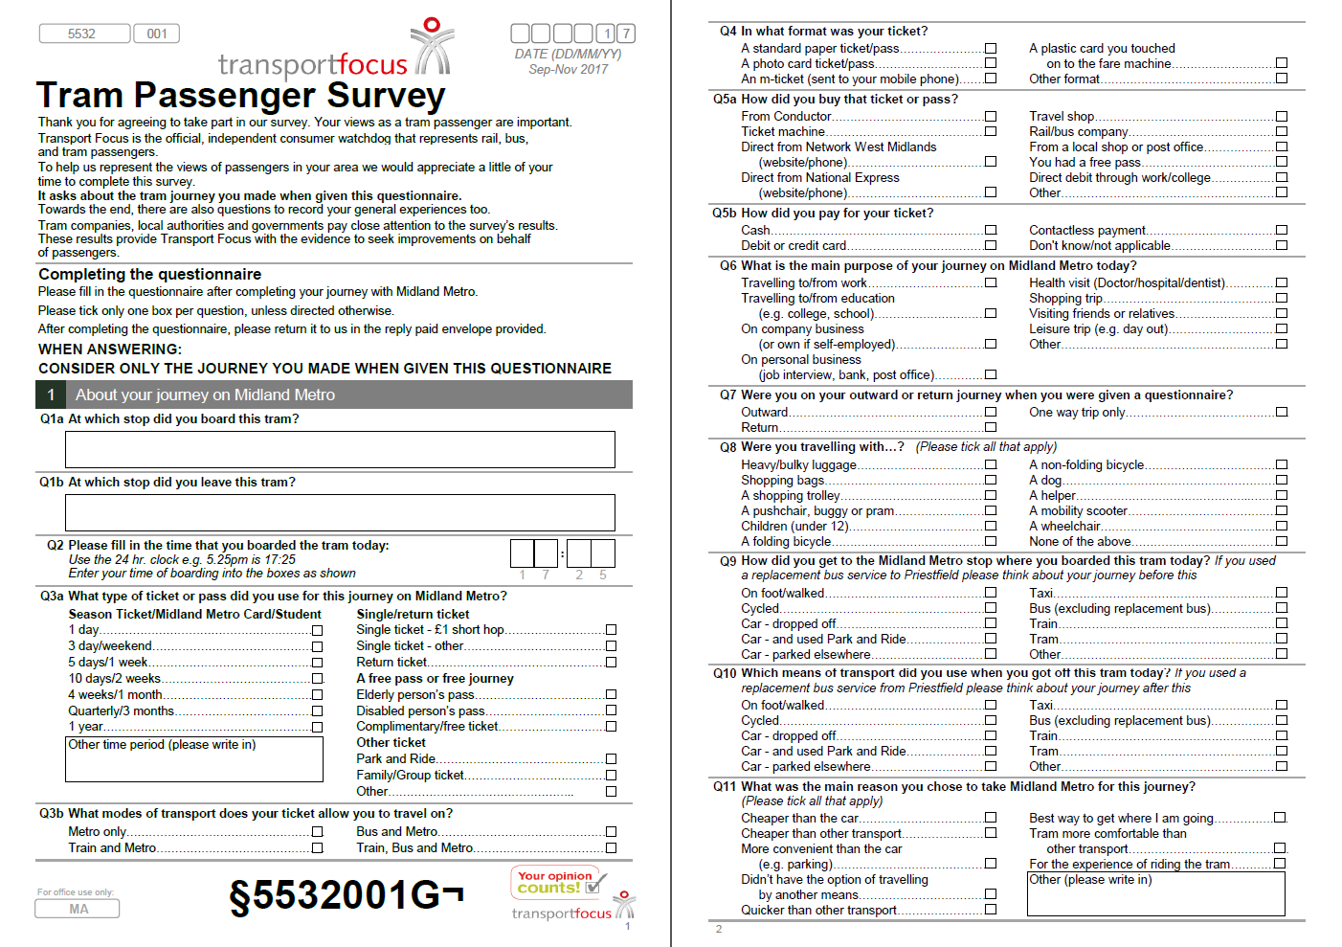
50
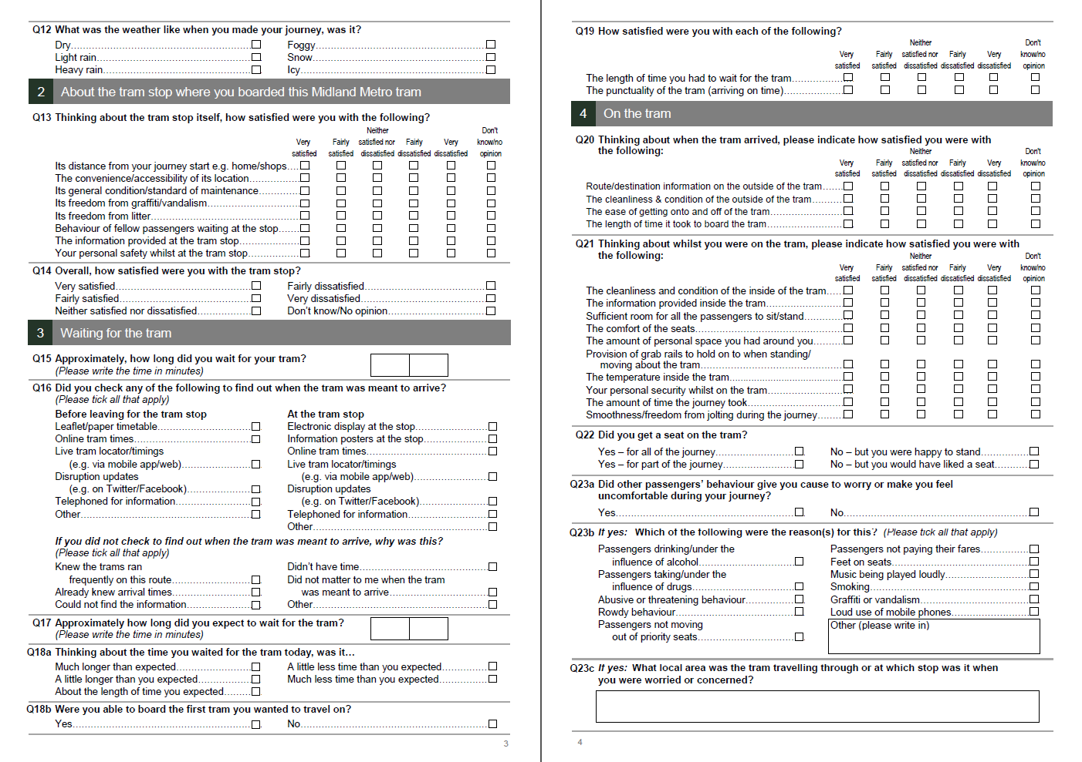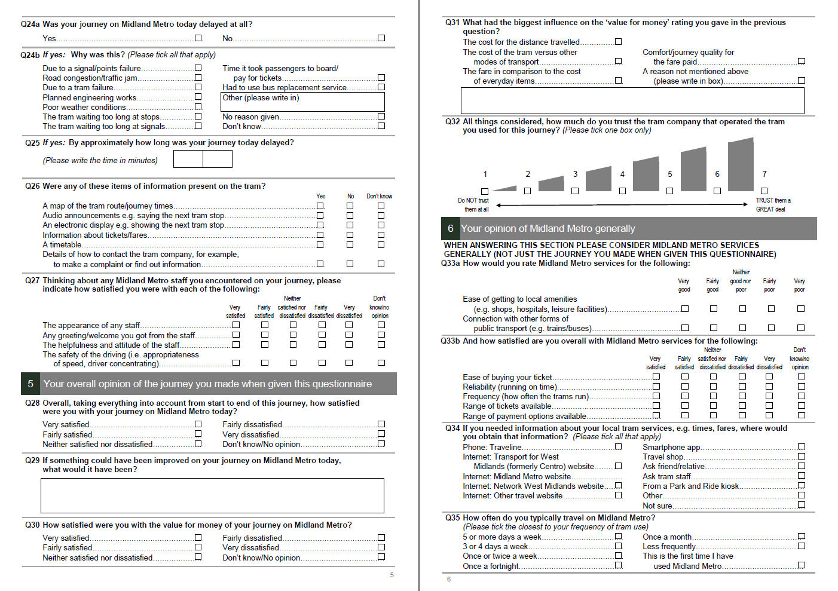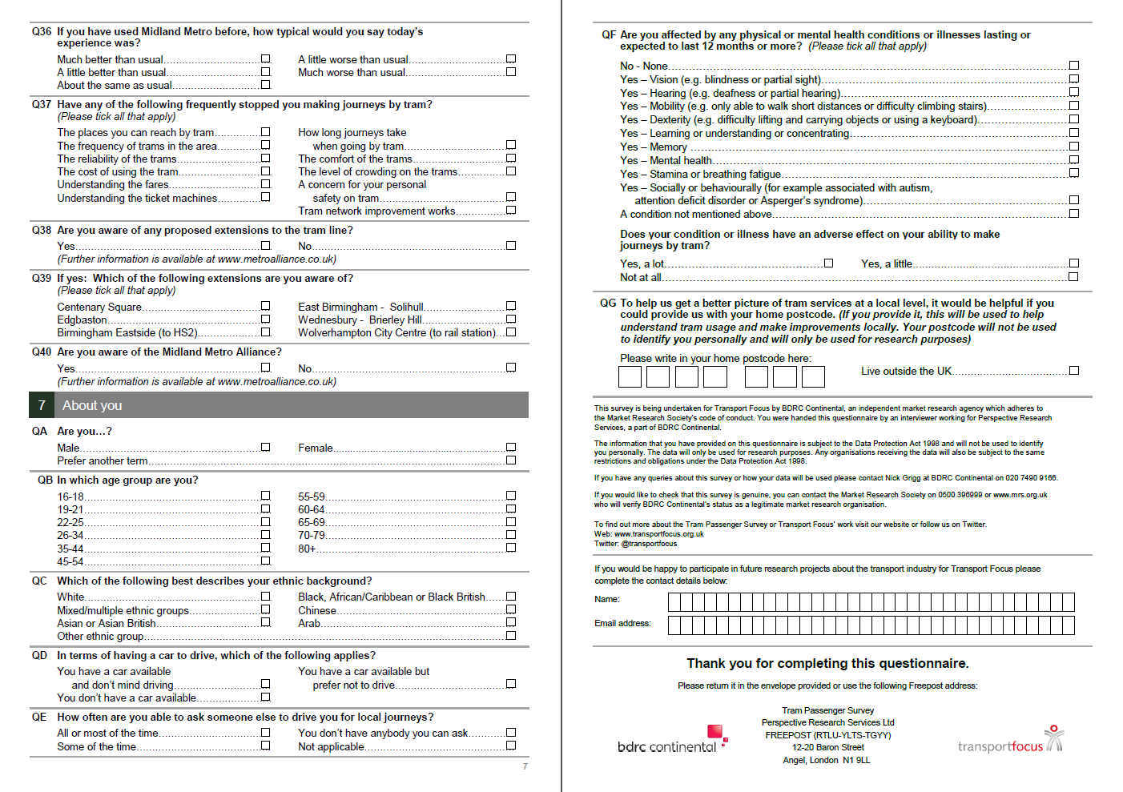
51
52
53

There are very few public transport services prior to 6am and the additional costs for running fieldwork at this time – hourly rates and transport to the start point – are not justified given the very small number of passengers. Although there are more journeys after 10pm, safety concerns rule out fieldworkers operating after this time – the only feasible option would be to ensure fieldworkers operate in pairs and again the cost of this and providing transport at the end of the shift is not justified given the relatively low number of passengers
‘Dayparts’ are: ‘Morning peak’ (weekdays 07:00-09:30), ‘Evening peak’ (weekdays 16:00-18:30), ‘Off-peak’ (weekdays at other times) and ‘Weekends’ (any time on Saturdays or Sundays).
https://www.gov.uk/government/collections/light-rail-and-tram-statistics
https://www.transport.gov.scot/publication/scottish-transport-statistics-no-35-2016-edition/SCT01171871341-10/#tb17

